**Blog on**

**Session 2021-2022**

**SUBMITTED TO SUBMITTED BY**

**Data Trained Education Sourabh Jhod**

**Content**

1. Problem Definition.

2. Data Analysis.

3. EDA Concluding Remark.

4. Pre-Processing Pipeline.

5. Building Machine Learning Models.

6. Concluding Remarks.

**Introduction**:

In this project, I have built a Machine Learning Classification model using Python. In this project I have used scikit-learn library to implement the classification problem,while using pandas for data manipulation and seaborn for data Visualization. This dataset includes details of applicants who have applied for loan. The dataset includes details like credit history, loan amount, their income, dependents etc.

**Problem Statement**:

This dataset includes details of applicants who have applied for loan. The dataset includes details like credit history, loan amount, their income, dependents etc. You have to build a model that can predict whether the loan of the applicant will be approved or not on the basis of the details provided in the dataset.

**Independent Variables:**

- ApplicantIncome

- CoapplicantIncome

- Dependents

- Education

- Gender

- Loan_ID

- Married

- Self_Employed

- Loan_Amount

- Loan_Amount_Term

- Credit History

- Property_Area

**Dependent Variable (Target Variable):**

- Loan_Status

**Importing our Dataset:**

First, we will import required library to import our dataset.

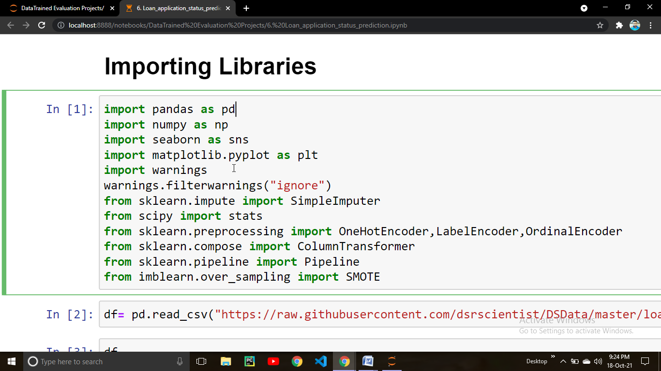

Here we imported some important python libraries like pandas for data manipulation ,numpy for advanced mathematical operations,Matplotlib & Seaborn for data visualization , scipy for some statistical computation ,Warnings for handling warnings during code execution.

**Loading Data set**

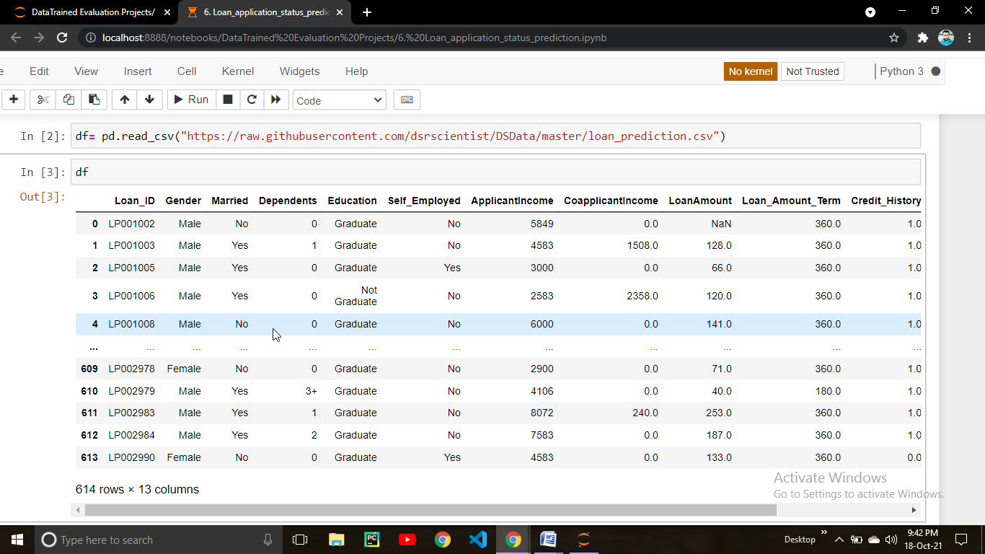

Here we loaded csv file from the url link

**Checking Shape of Data**

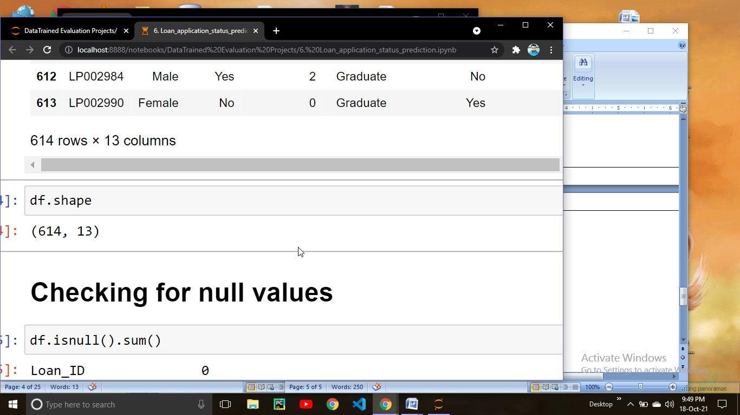

From this command we can check what is the shape of our data set.

Here pandas return (614 , 13) which means our data has 614 rows and 13 columns**.**

**Checking for null values**

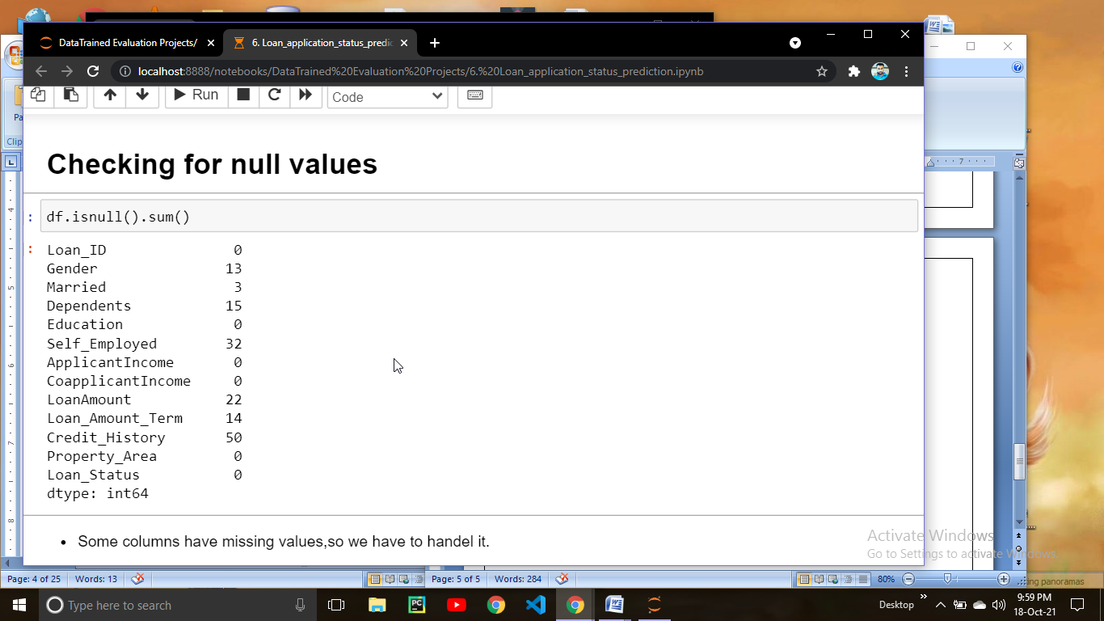

Here we are checking for null values in our data for that we have to use dataframe.isnull().sum() command which will return the counts of null values present in each of the columns for Example Gender = 13 means Gender column has 13 null value.

Lets check the missing values in much more clear way in the form of percentage.

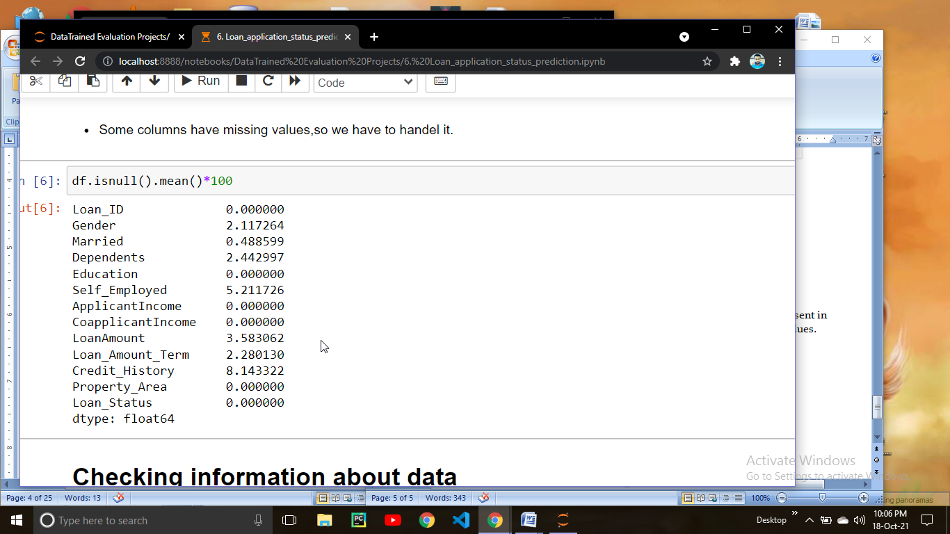

Here we check what percentage of missing value is present in each columns.

**Checking information about data**

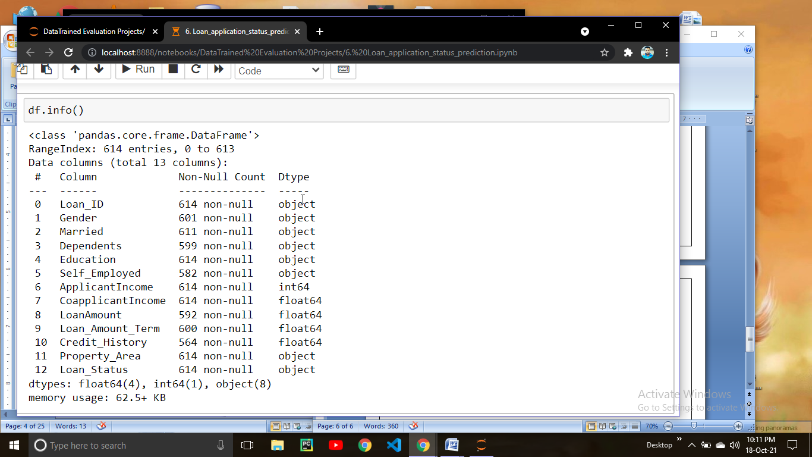

To check the more information about data you can use dataframe.info() command which will return the information which includes datatype of each column,how many entries are present in the data, count of null values present in columns & memory usage.

**Checking mathematical aspects about data**

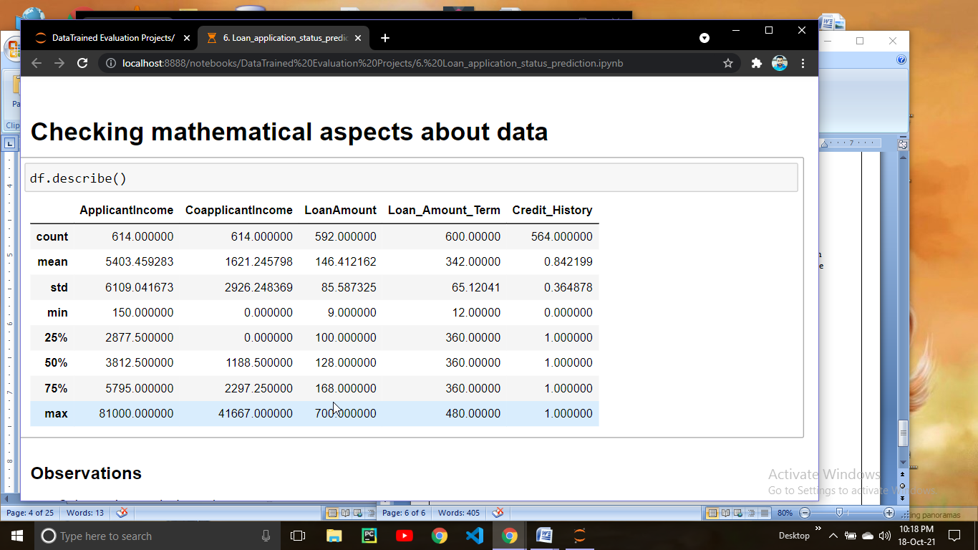

To check how the data behaves mathematically you can use DataFrame.describe() command. This command returns a table which contains Count,mean,std(standard deviation),min(minimum value),25% (25th quantile) , 50% (50th quantile or median value),75% (75th quantile) and max (maximum value). Always keep this in mind that describe function returns the statistics for only numerical variables and not for the categorical variable.

From the above example we can observed that:-

* Columns have missing values.
* In ApplicantIncome column mean is greatter then median hence it shows column have outliers and skewness.
* In CoapplicantIncome column mean is greatter then median hence it shows column have outliers and skewness.
* In Credit_History column looks like there are only two values 1 and 0 .
* In Loan_Amount_Term median is greater then mean and mininum value is so far from 25th percentile hence left skewed column.
* In LoanAmount column median is greater then mean hence data is left skewed and have outliers

# Checking Correlation

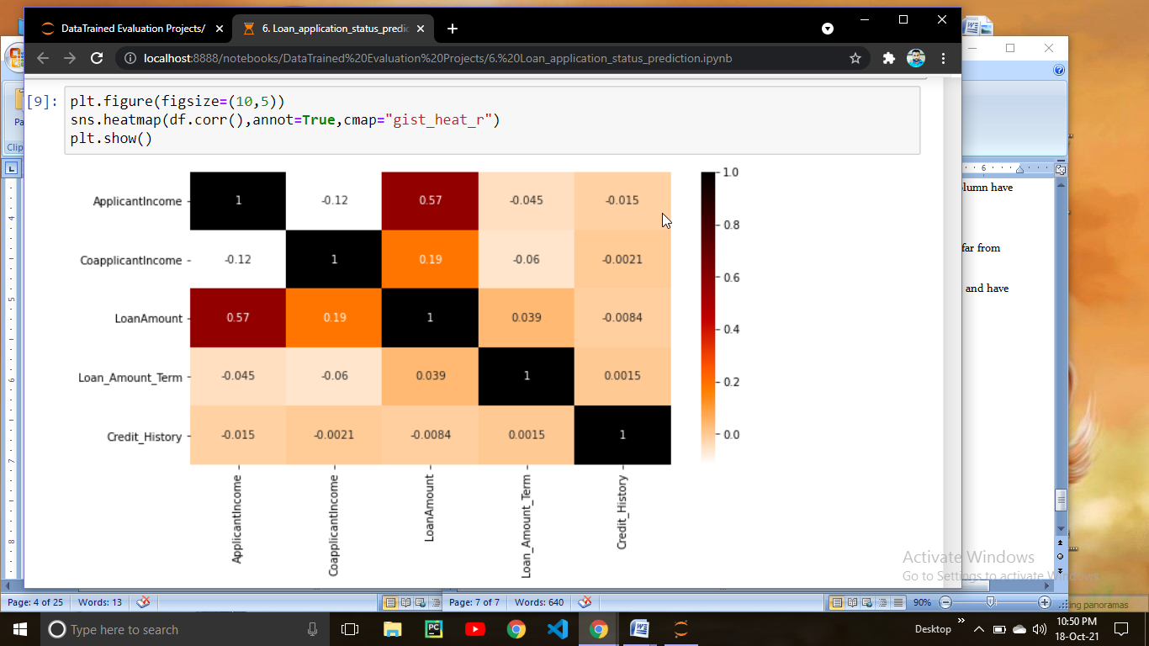

Here we are checking for the correlation for that we are using DataFrame.corr() command. This command will return correlation co-efficient for each columns with each other. By Default corr() function use Pearson’s correlation but you can use “kendall tau” or “spearman rank” correlation.

# Saperating numericals & categorical columns

Now what we are going to do here is saperating the numerical variable & categorical variable which can help you to perform better Preprocessing on data.

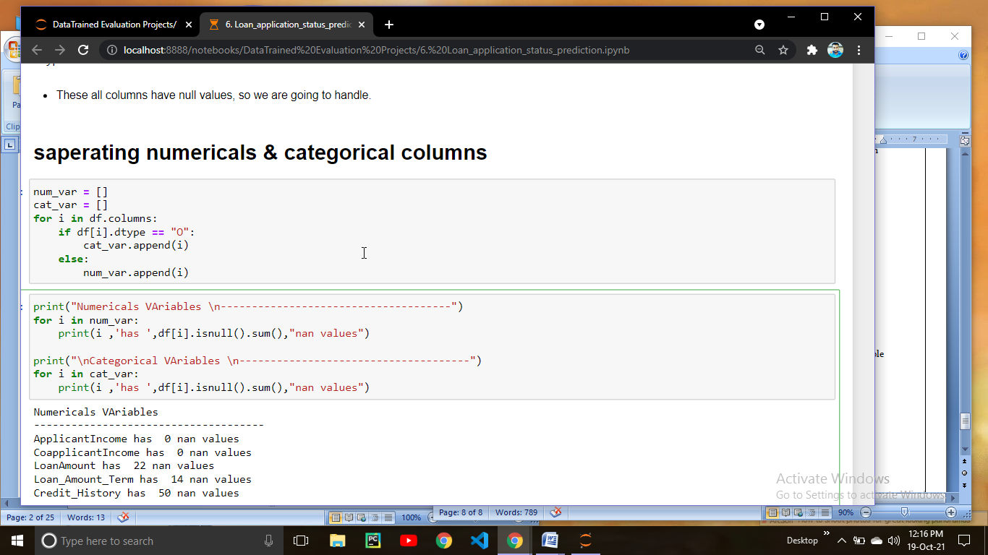

For saperating the variables we are going to run a for loop before that we initialized two empty list num_var and cat_var. we will run for loop on df.columns saying if dtype if column is equal to “object” append column into cat_var list else append it into num_var list. By running this code your numerical variable & Categorical variables get saperated.

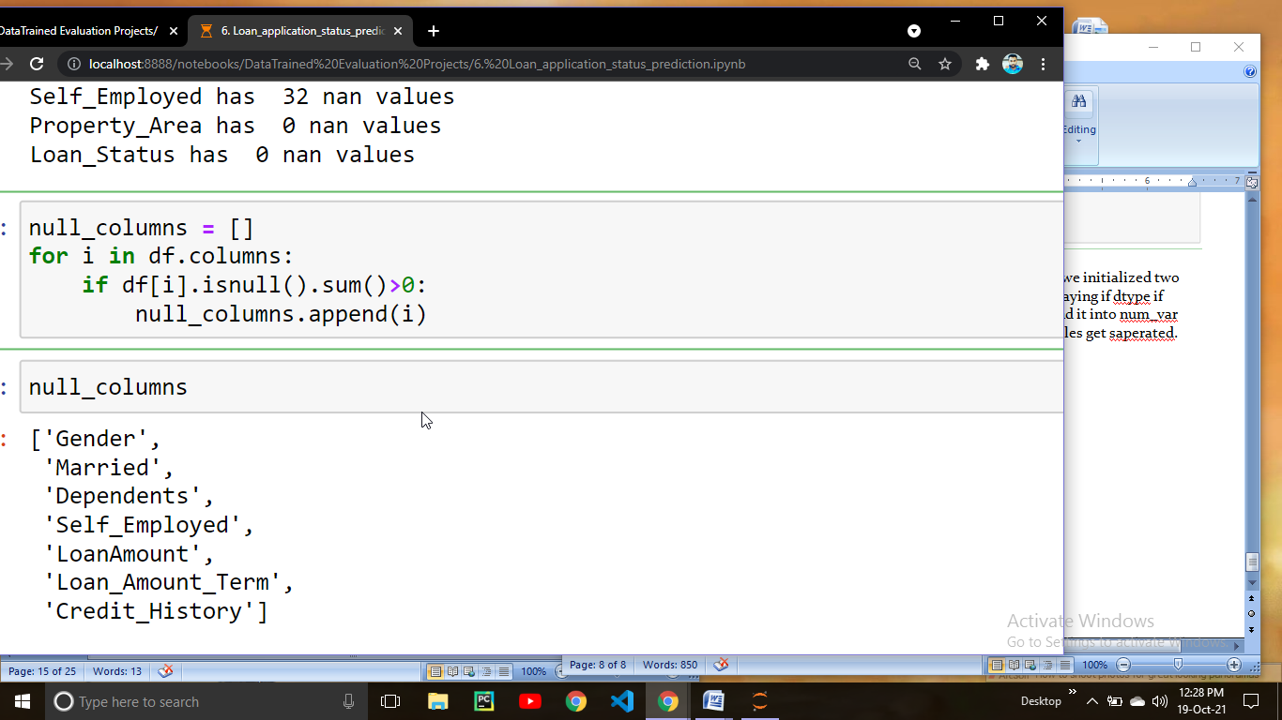

Here we printed the columns name which contains null values.

**Replacing the null values with mode value**

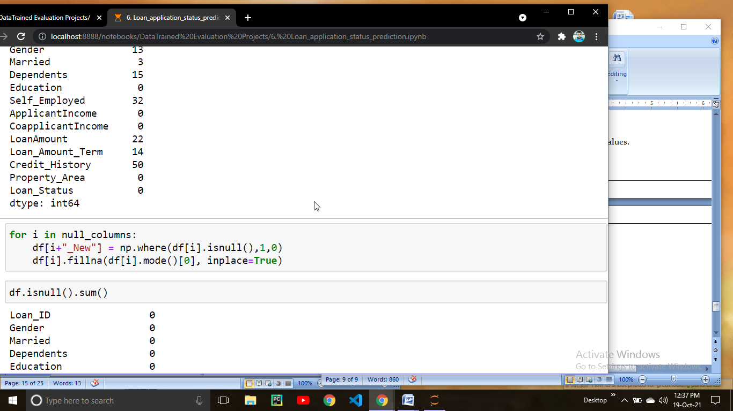

What we did here we are going to make missing indicator column which contains binary values 0 & 1 . This column will indicate 1 means value is missing and 0 means value is missing. There are few more ways to make missing indicator. First is in sklearn Simple imputer a parameter called “***add_indicator***” this parameter is by default “**False”** but if you make it “**True”**  used to add binary indicators for missing values. Another Techenique is “**MissingIndicator**” we can import this from **from** **sklearn.impute** **import** MissingIndicator ,this will add a Binary indicators for missing values. After making missing indicator column imputing missing value with mode value in each column.

##### **In Dependents columns values are of numeric type but data type is object because of 3+ value, so we have to convert it into numeric value**

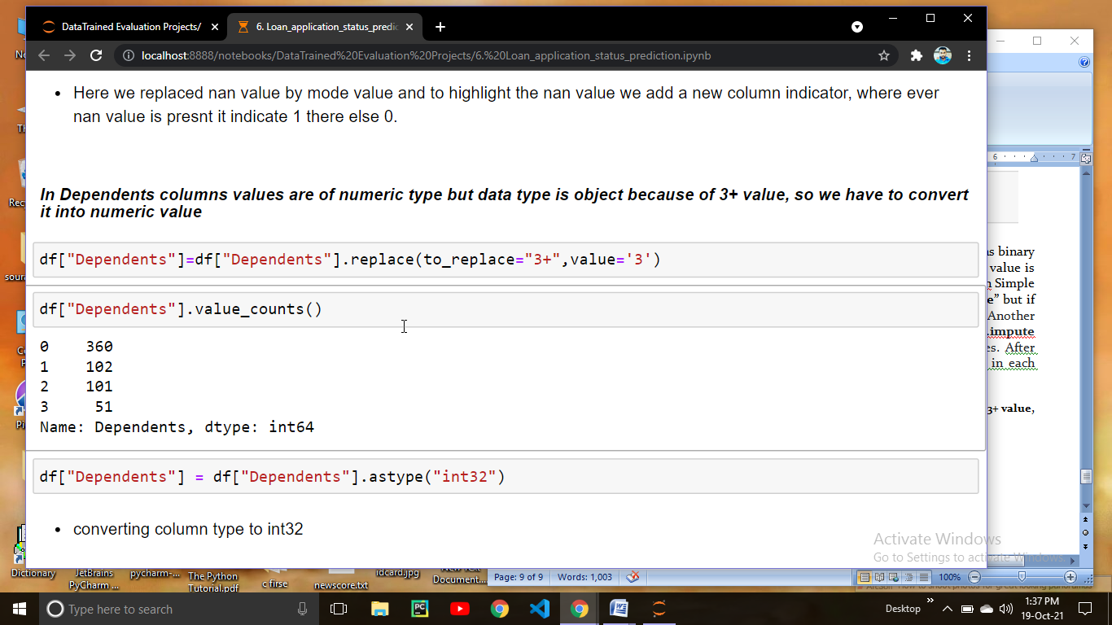

When we checked Dependents column it is of object type but the value in the column are of numeric but because of 3+ column is converted as object so we have to remove “+” sign and convert the column into int32.

# Exploratory Data Analysis

Exploratory Data Analysis refers to the critical process of performing initial investigations on data so as to discover patterns,to spot anomalies,to test hypothesis and to check assumptions with the help of summary statistics and graphical representations.

It is a good practice to understand the data first and try to gather as many insights from it. EDA is all about making sense of data in hand,before getting them dirty with it.

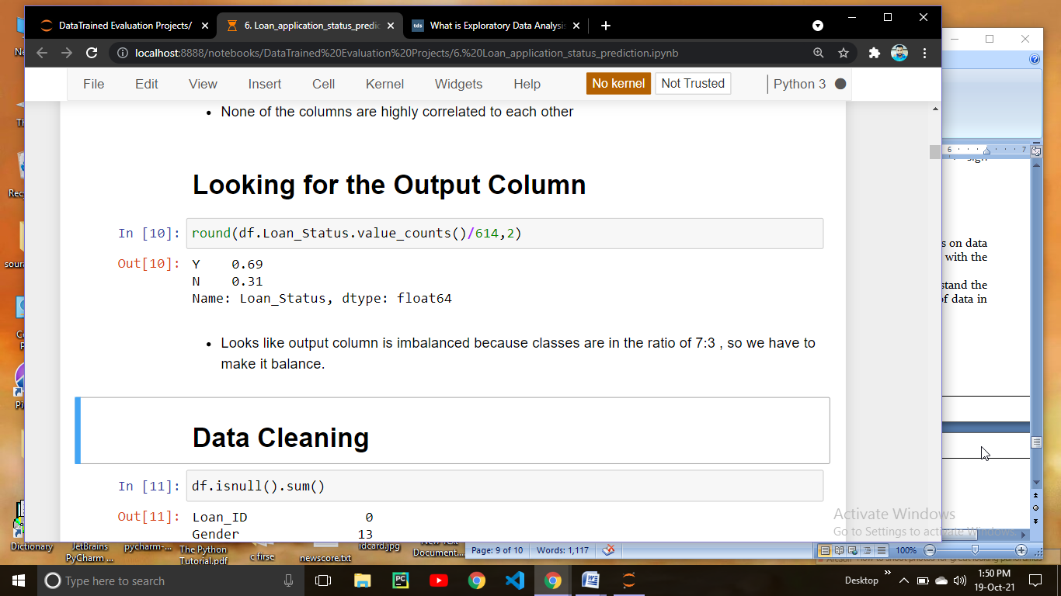

When we checked the value counts of output column we get to know that our classes in output column are not balanced hence this is the case of imbalanced data.

Imbalanced classification refers to a classification predictive modeling problem where the number of examples in the training dataset for each class label is not balanced. That is, where the class distribution is not equal or close to equal, and is instead biased or skewed

In our case data is in the ratio of 7:3 which is clearly a case of imbalanced data so there are some techniques to make data balance

From here we are going to start Data visualization from which we can get the proper idea about the data. Data visualization is the representation of data or information in a graph, chart, or other visual format. It communicates relationships of the data with images. This is important because it allows trends and patterns to be more easily seen. With the rise of big data upon us, we need to be able to interpret increasingly larger batches of data.

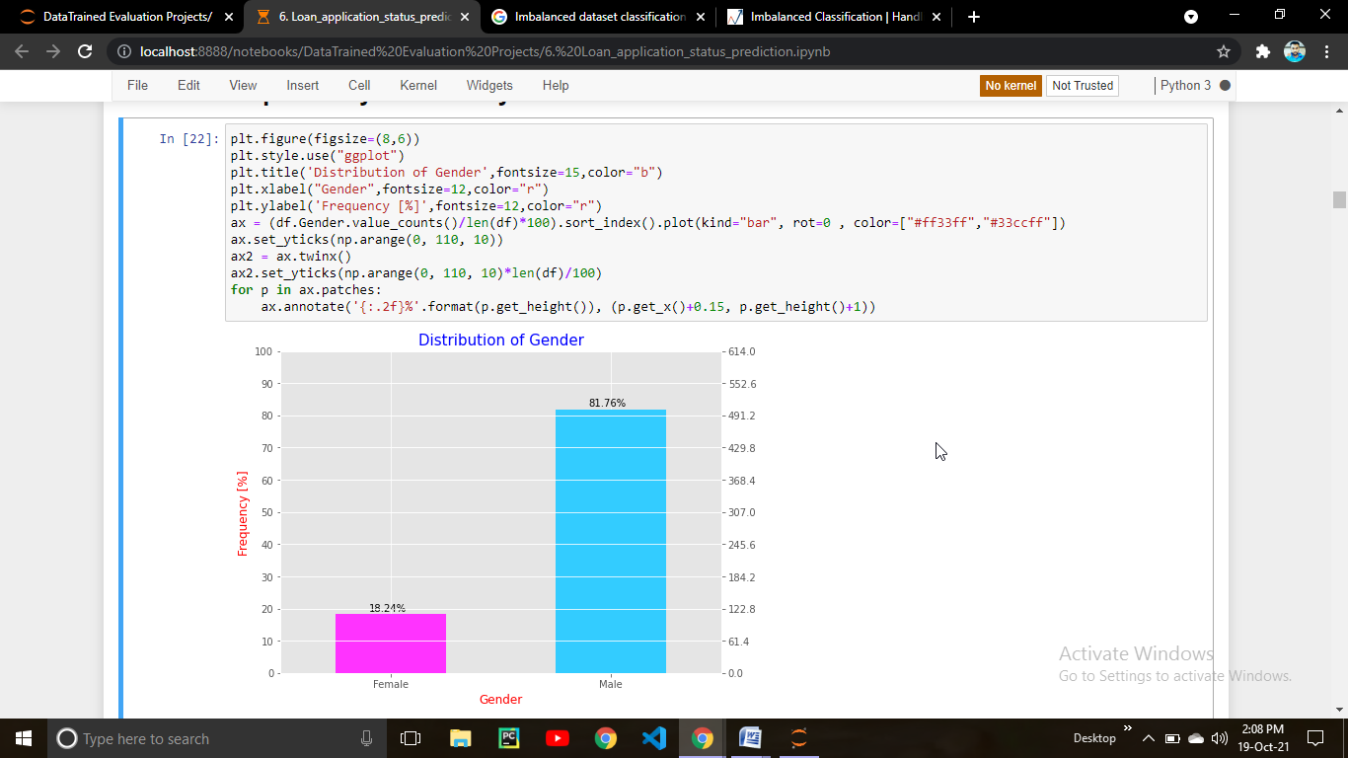

Here we ploted a bar plot through which we can get a knowledge about the male & female percentage in the data. From the above bar plot it is clear that male are 81.76 % of overall population and 18.24 % are of Female population. In above code I wrote some styling to make bar plot more readable but you can plot a simple bar plot using seaborn.

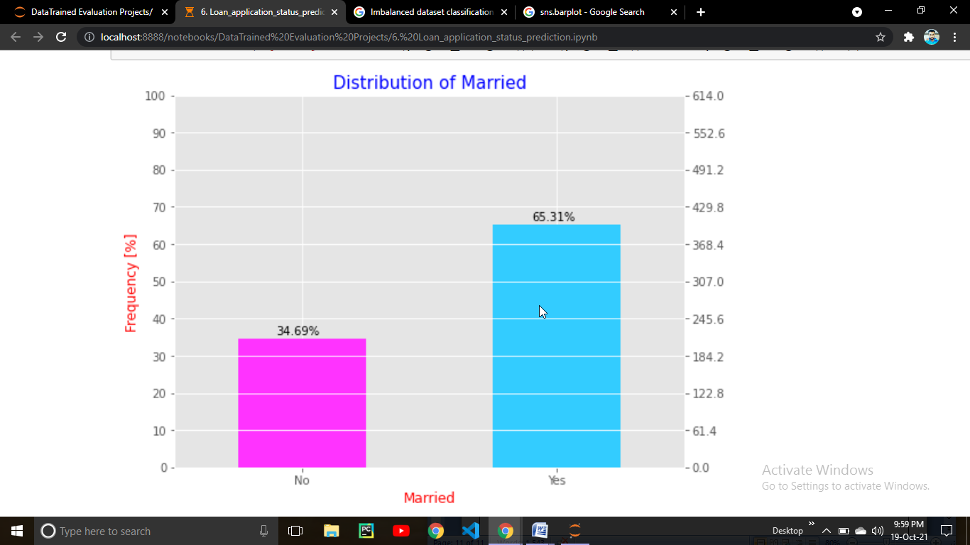

Here we ploted a bar plot to check wheather the population in the data is married or not.

We can get a idea about the population that 65.31 % people in the data are married and 34.69 % are unmarried.

Lets do some more EDA on Married status

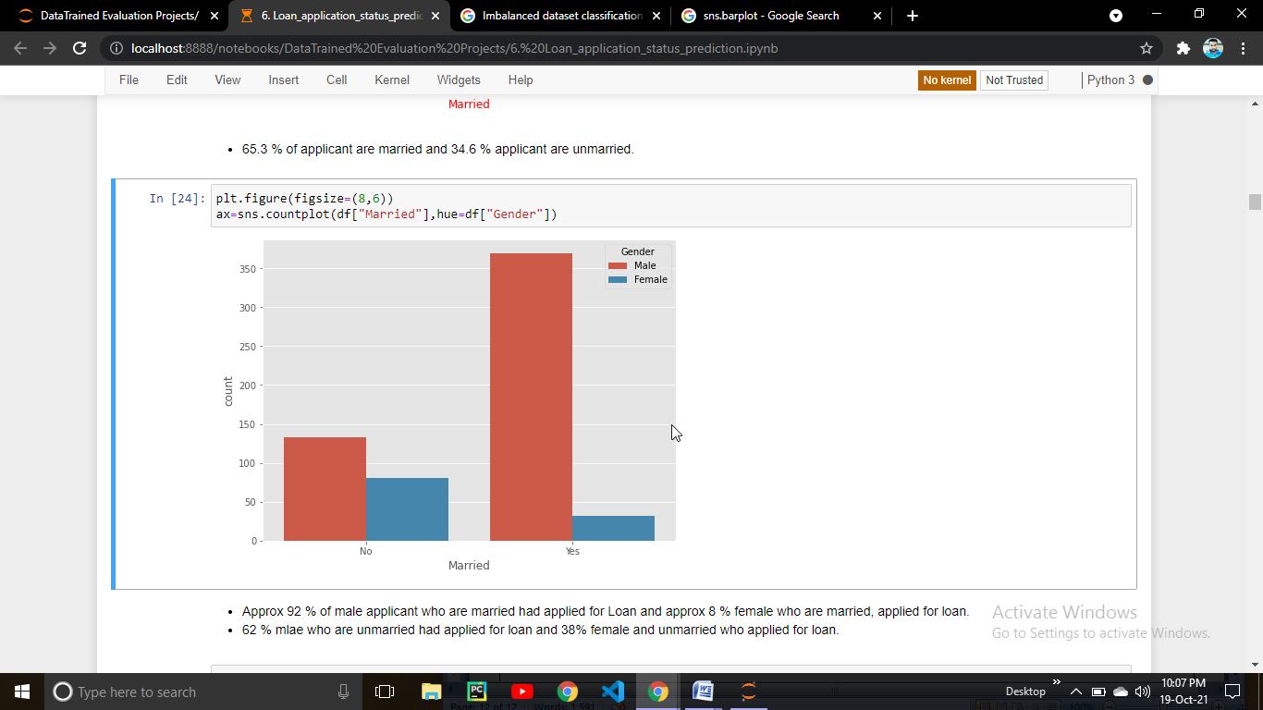

Here we get to know from the above countplot that population who are male get married more as compare to female population in our data. Approx 92 % of male applicant who are married had applied for Loan and approx 8 % female who are married, applied for loan. 62 % mlae who are unmarried had applied for loan and 38% female and unmarried who applied for loan.

Lets check the Education column in the data

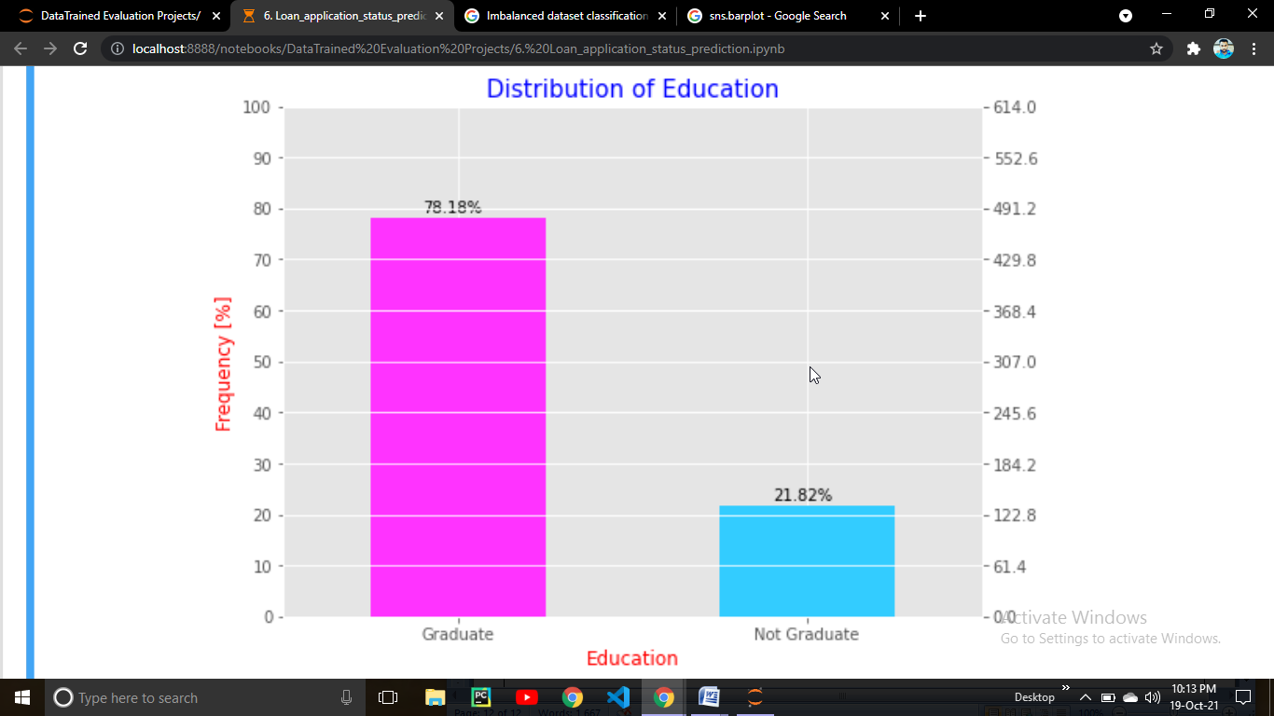

78.18 % are Graduated applicant and 21.8 % are Not Granduated applicant who had applied for loan.

Lets Check the Self_Employed column

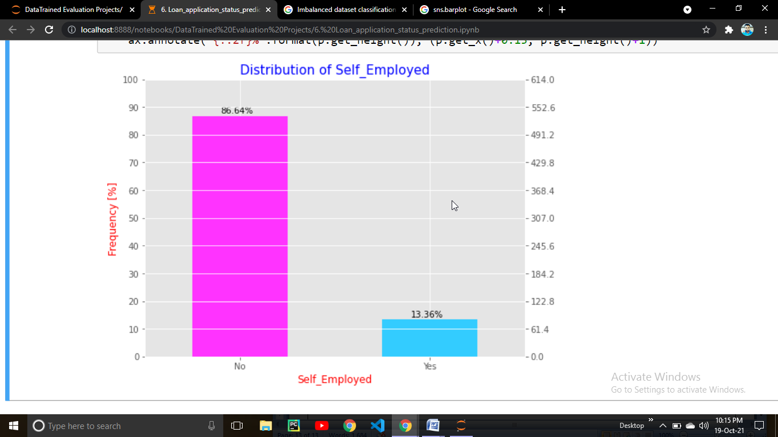

From the above plot we get to know that very less number of people only 13.36 % are Self Employed else all are (about 86.64 %) working somewhere

Lets check the what is the impact of education on self employment.

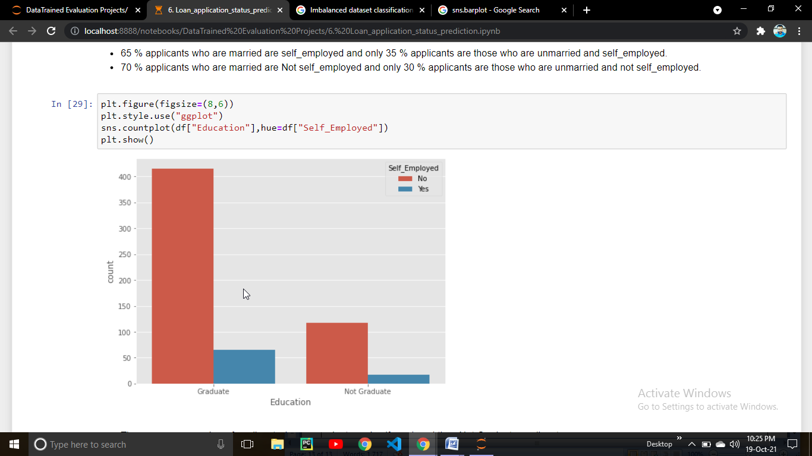

There are maximum number of applicant who are graduate but not self employed &

There are more number of applicant who are graduate and self employed then Not Graduate applicant.

Lets check the impact of gender on Education.

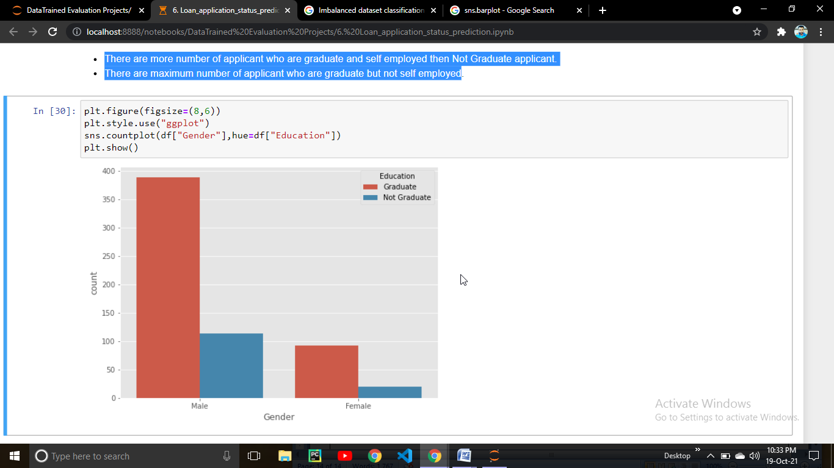

From the above plot we can make a observation that majority of the male applicant are graduated.

Now lets check the distribution of Property_Area in the data

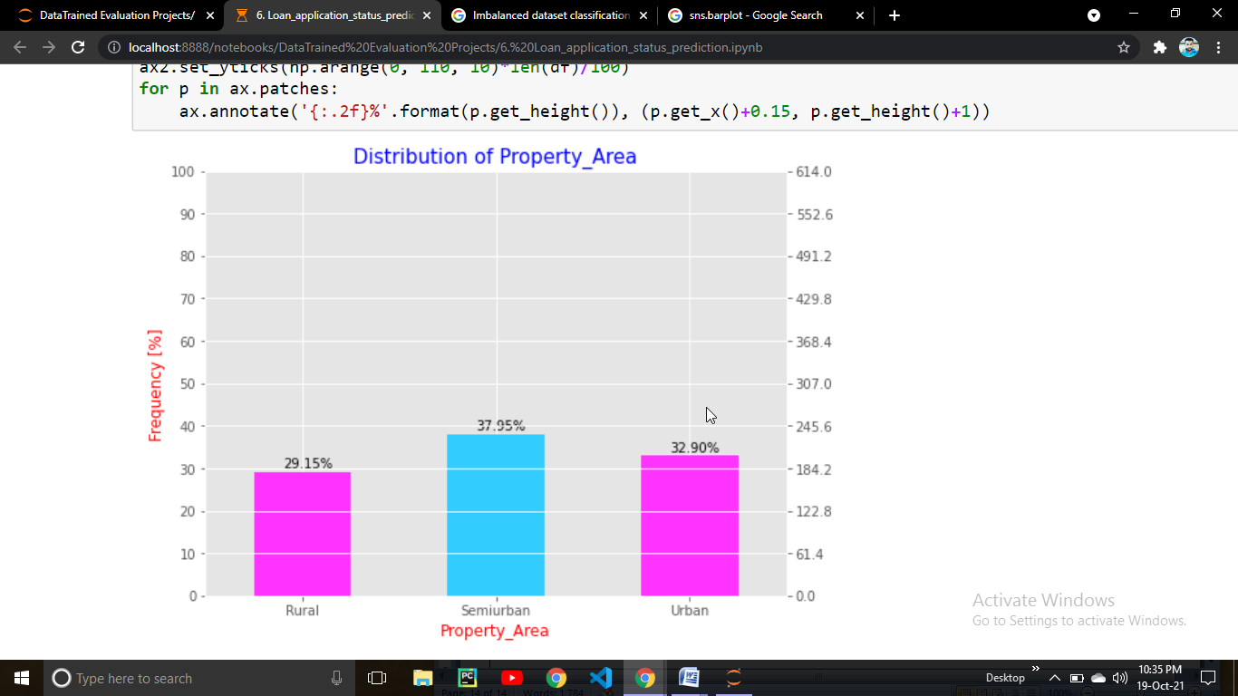

From the above plot we can make a observation that 37.9 % applicant are from semiurban area , 32.9% are from Urban area and 29.15 % are from Rural area

Lets check from which area maximum number of applicant have applied for the loan.

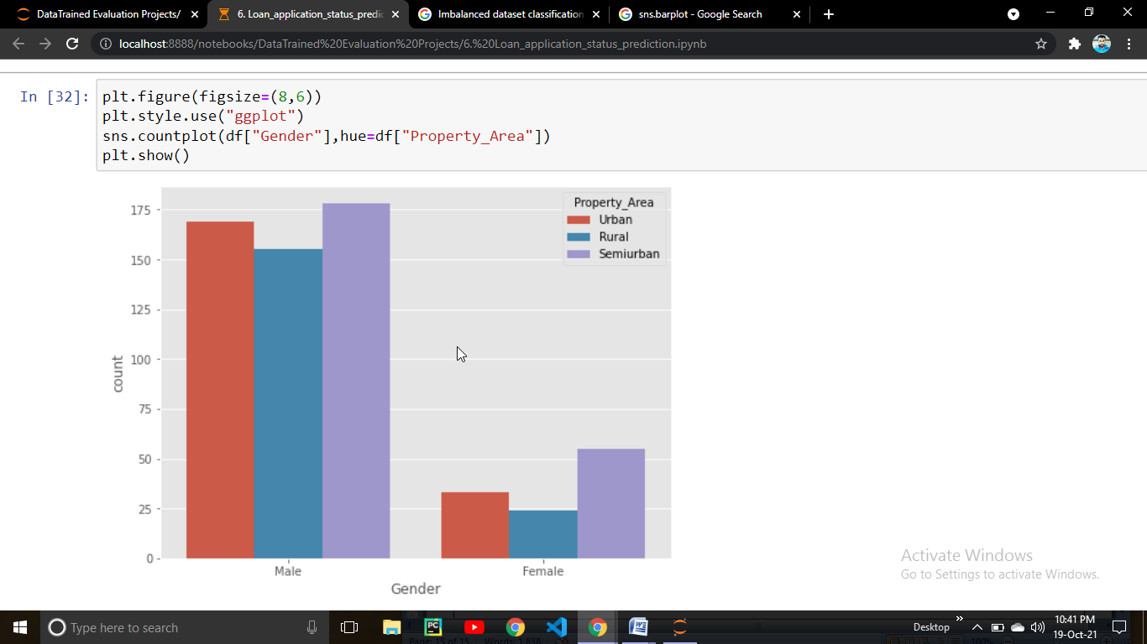

From the above observation we can get to know that from semi urban area maximum male and female applicant have applied for the loan and as compare to semiurban area there are less applicant from rural area in both the gender.

Lets check which gender get the loan approval more

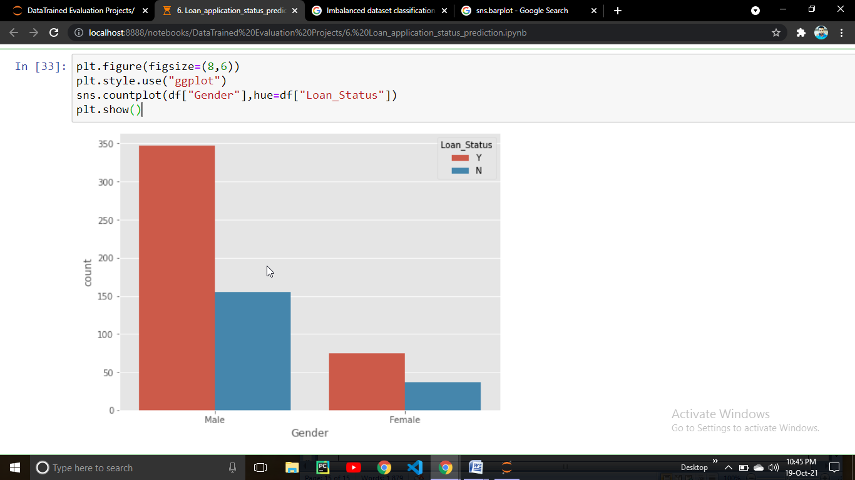

From the above plot we can get a idea about if a applicant is male the chances of getting loan approval is higher as compare to female . 69.1 % from the total male applicant would have got loan and 30.8 % male would not have got the loan. 66.9 % from the total Female applicant would have got loan and 33.1 % Female would not have got the loan.

Lets check the impact of education on loan approval

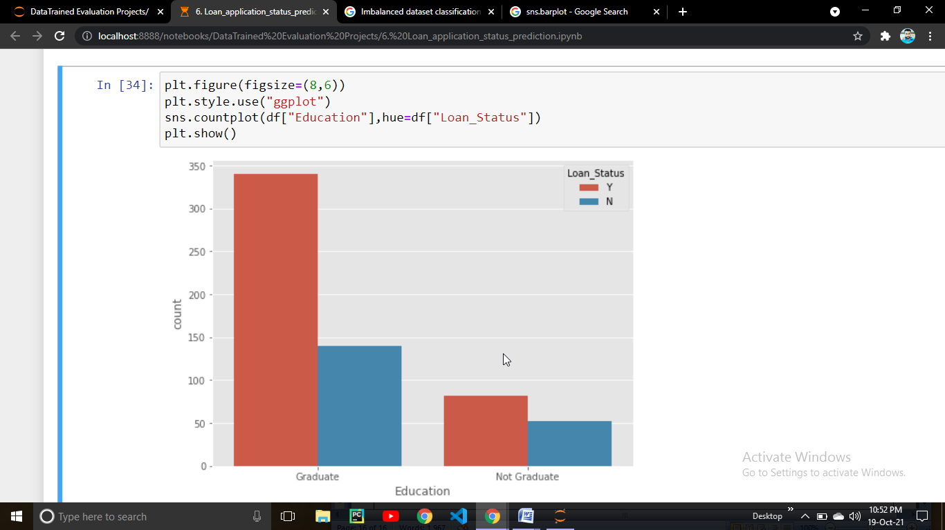

From the above plot we can observed that 70 % applicant who are graduate would have

got loan & 61 % applicant who are Not graduate would have also got loan. So basically education is not a factor of getting loan approve to applicant who have applied for loan.

Lets check the impact of property area on loan approval.

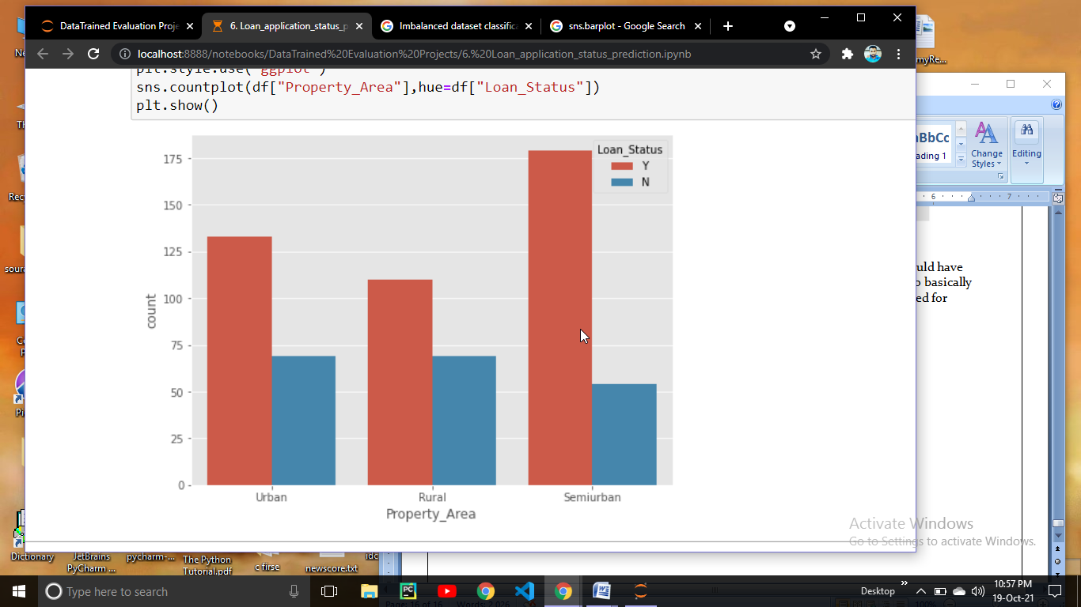

From the above plot we can clearly see that Applicant from semiurban area have 76% chance of getting loan approval , Applicant from Urban area have 65% chance of getting loan & if a Applicant is from Rural area there is 61% chance of getting loan approval. So we make a conclusion that if a applicant is from semi urban area there is a higher chance of getting loan approval.

Lets check the relation between ApplicantIncome & LoanAmount

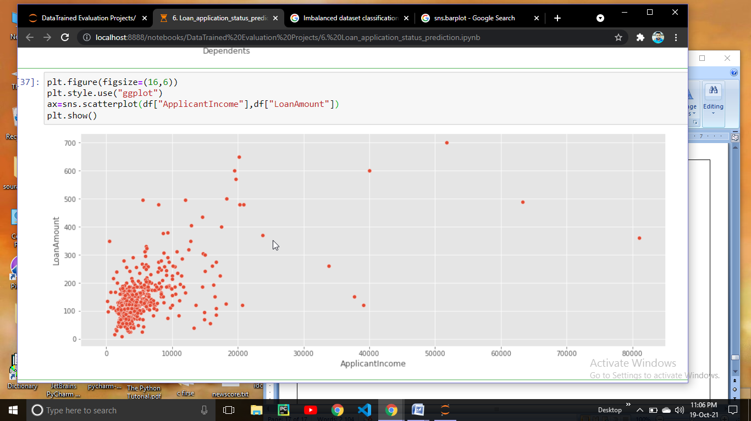

From the above scatter plot it is clear that applicant who have less income needs loan . people from mid range 3000 - 60000 will not applied more for loan.

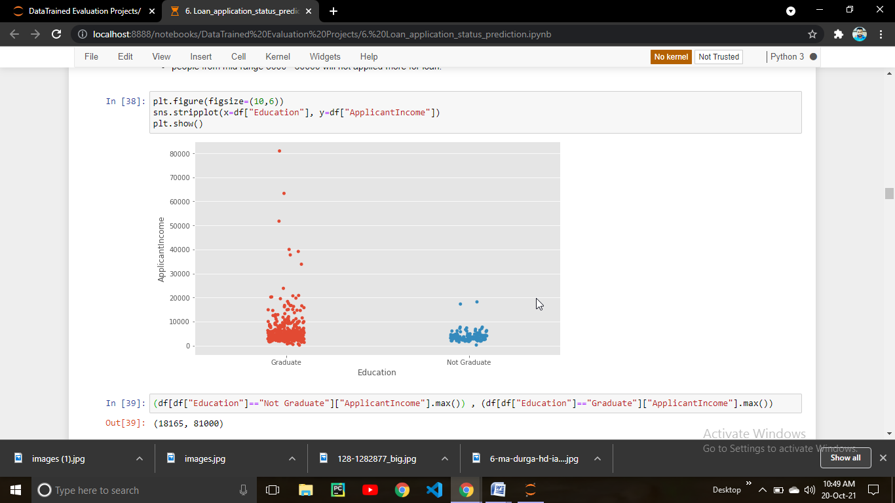

From the above observation we can see that the applicant who are graduate have more income as compare to not graduate applicant.

Lets check the impact of property_area & LoanAmount on loan status

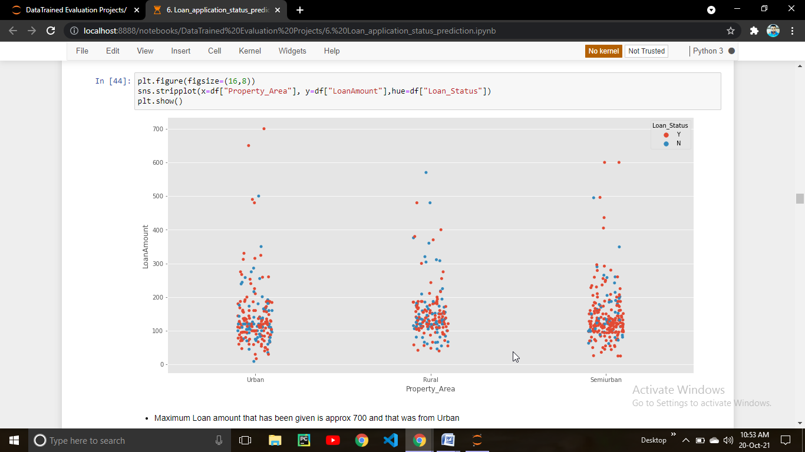

We can get a knowledge from the above strip plot that in urban area if a applicant applied for a loan amount about 700 there is a chance that applicant might get a loan , In Rural area if a applicant applied for a loan amount about 100 – 200 there is a chances that applicant get loan but if he applied for loan amount more that 350 there are less chances of getting loan approval. But if a applicant is from SemiUrban area there is a higher chance of getting a loan approval.

Lets check the pair plot

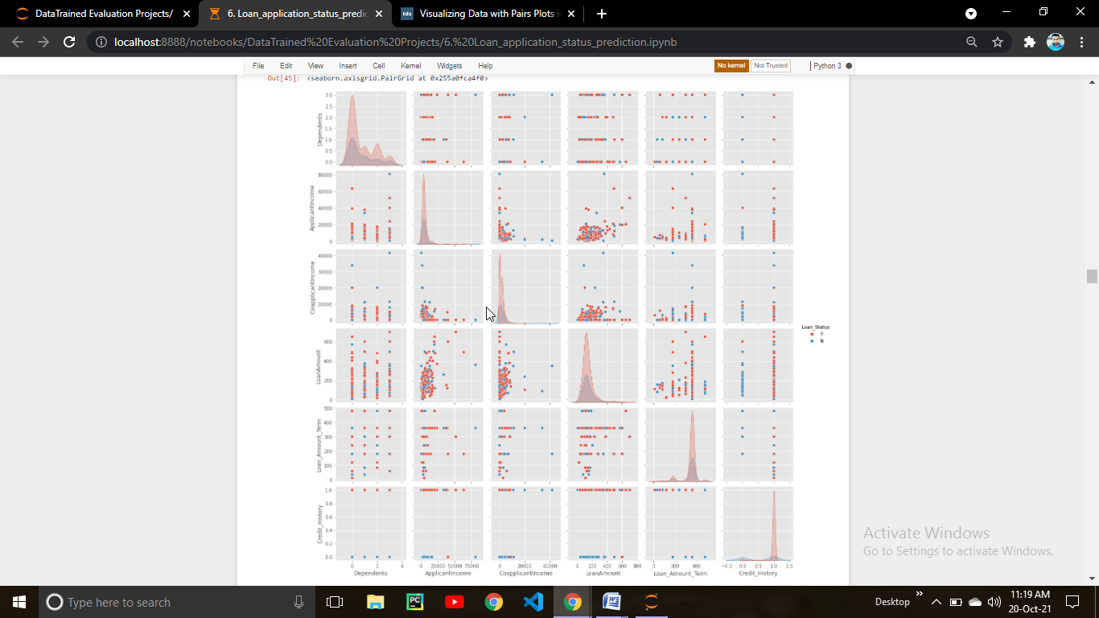

Lets Check the Outliers in columns.For checking outliers we are going to use Box plot. While using box plot you should keep this in mind that box plot will only applicable for numerical variables and not for categorical variable.

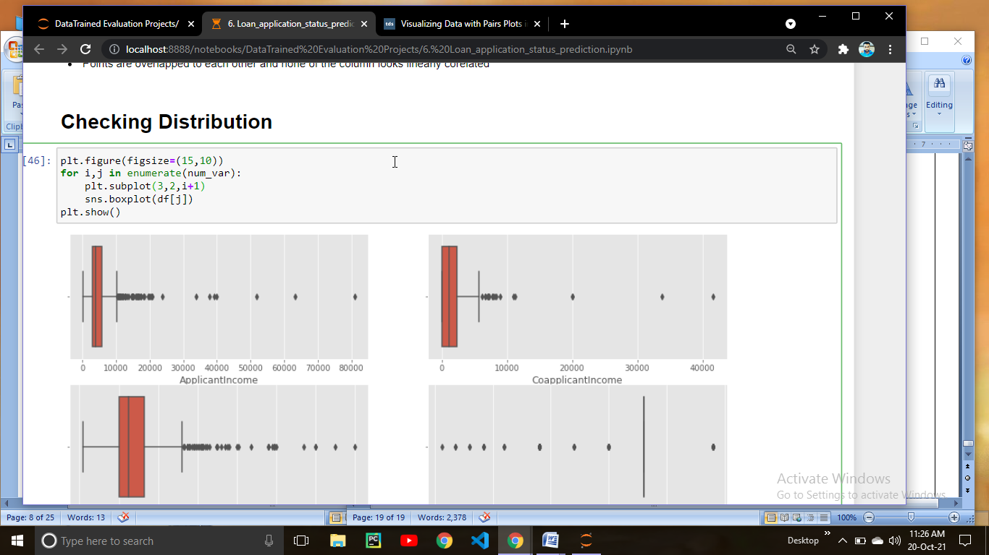

Here what we did is run a for loop on num_var (list that contains all the numerical variables) and creating a subplot to plot a box plot. After executing the code we get the output below.

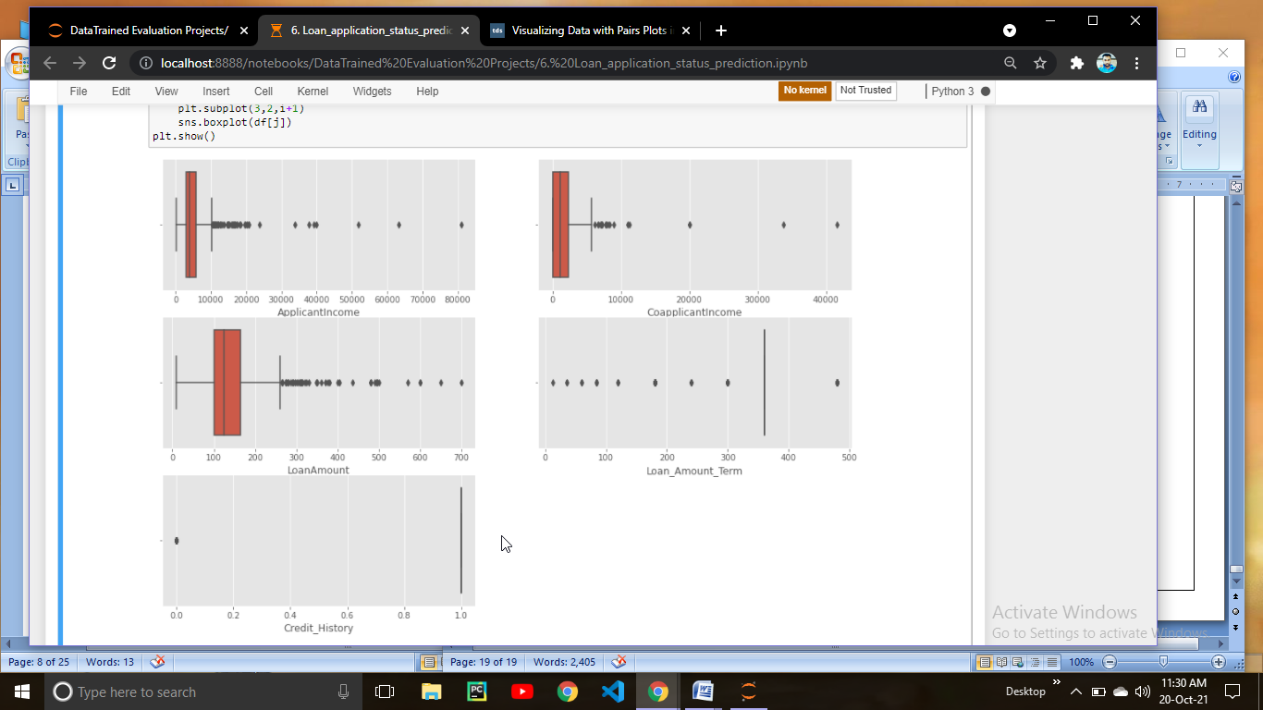

From the above plot we can observed that ApplicantIncome , CoapplicationIncome and LoanAmount has outliers so we have to remove them using IQR method.

Lets apply the IQR method

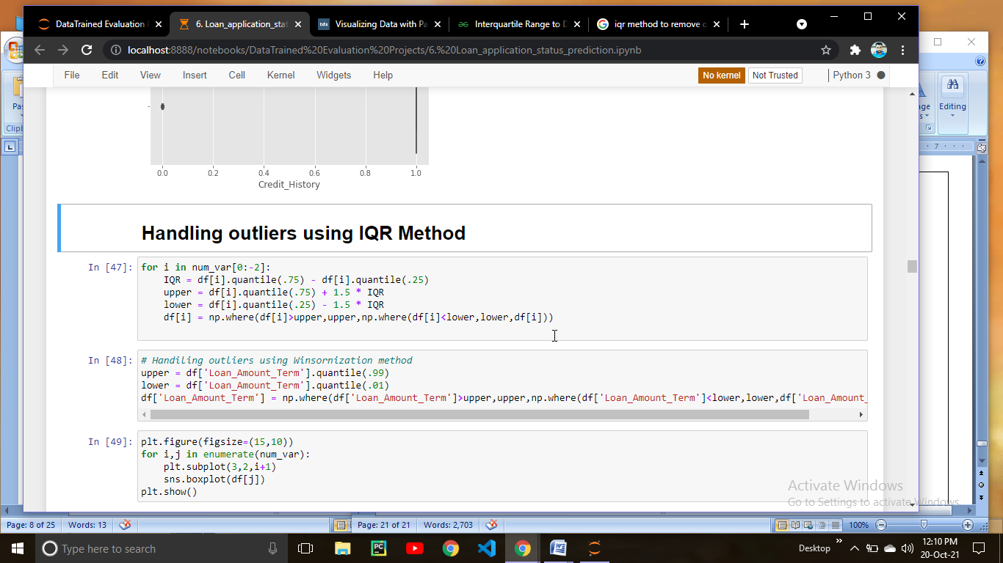

Here we applied the IQR method to remove outliers lets check wheather outliers are removed or not, for that we have to plot box plot one more time

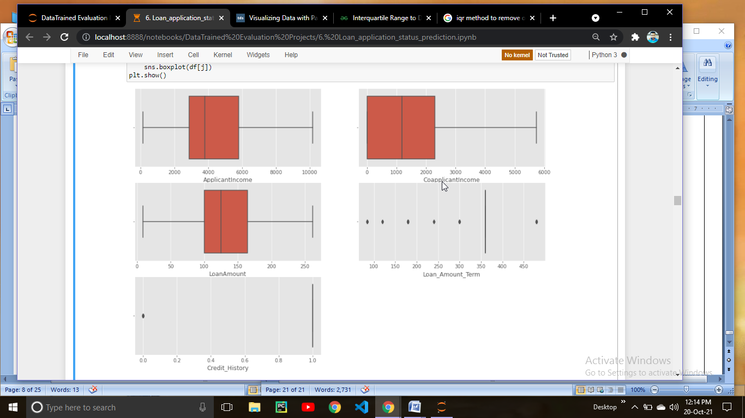

Here we can see that outliers has been removed from the columns , Now lets check the Distribution of data.

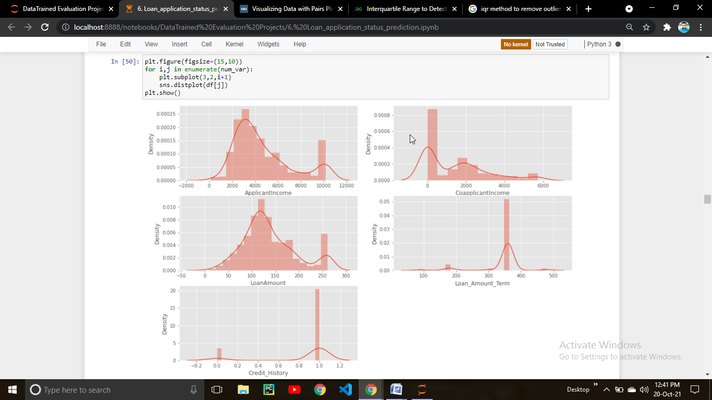

As we ploted a dist plot we can get a knowledge of data distribution. We can see that ApplicantIncome,CoapplicantIcome column are right skewed,LoanAmount looks normally distributed and Loan_amount_Term and Credit_History looks left skewed so lets convert it into normal distribution. But before permorming any transformation lets check the skewness using skew() function.

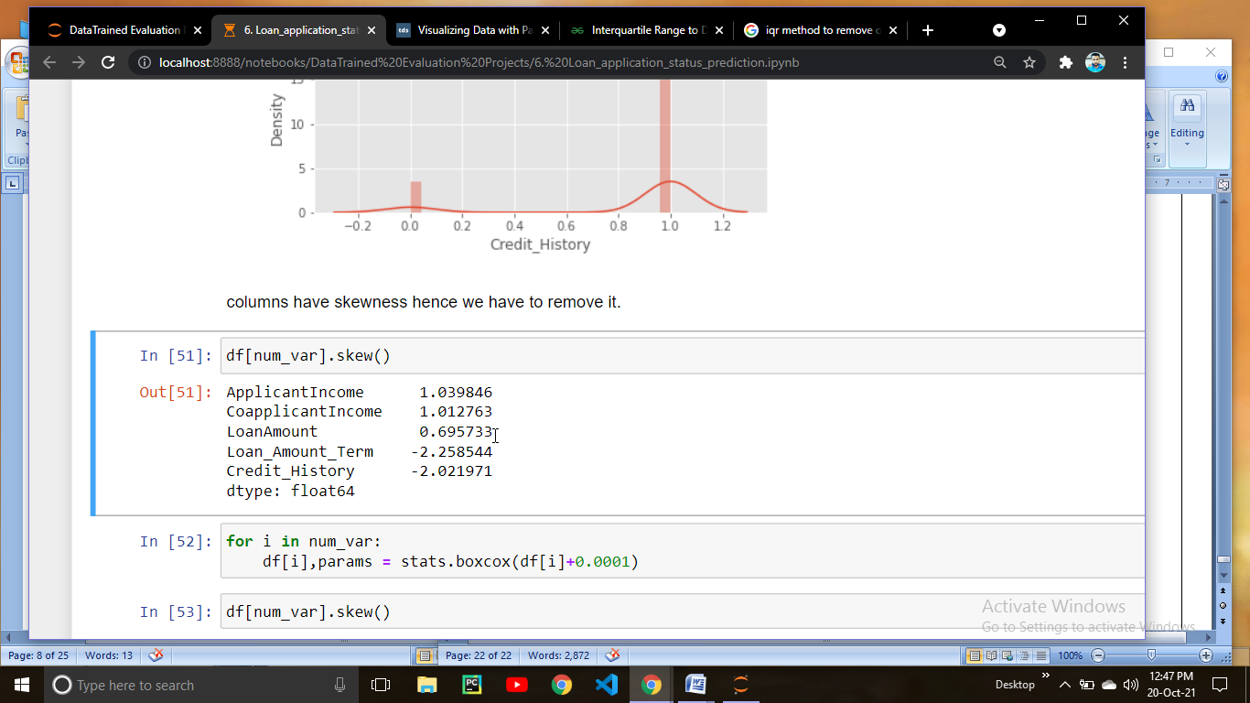

Yes we observed right ApplicantIncome & CoapplicantIncome column are right skewed,LoanAmount column looks almost normally distributed and Loan_Amount_Term & Credit_History are left skewed.

Although there are many different techeniques to remove skewness but we are using boxcox from scipy library . To use boxcox you have to import from scipy import stats.

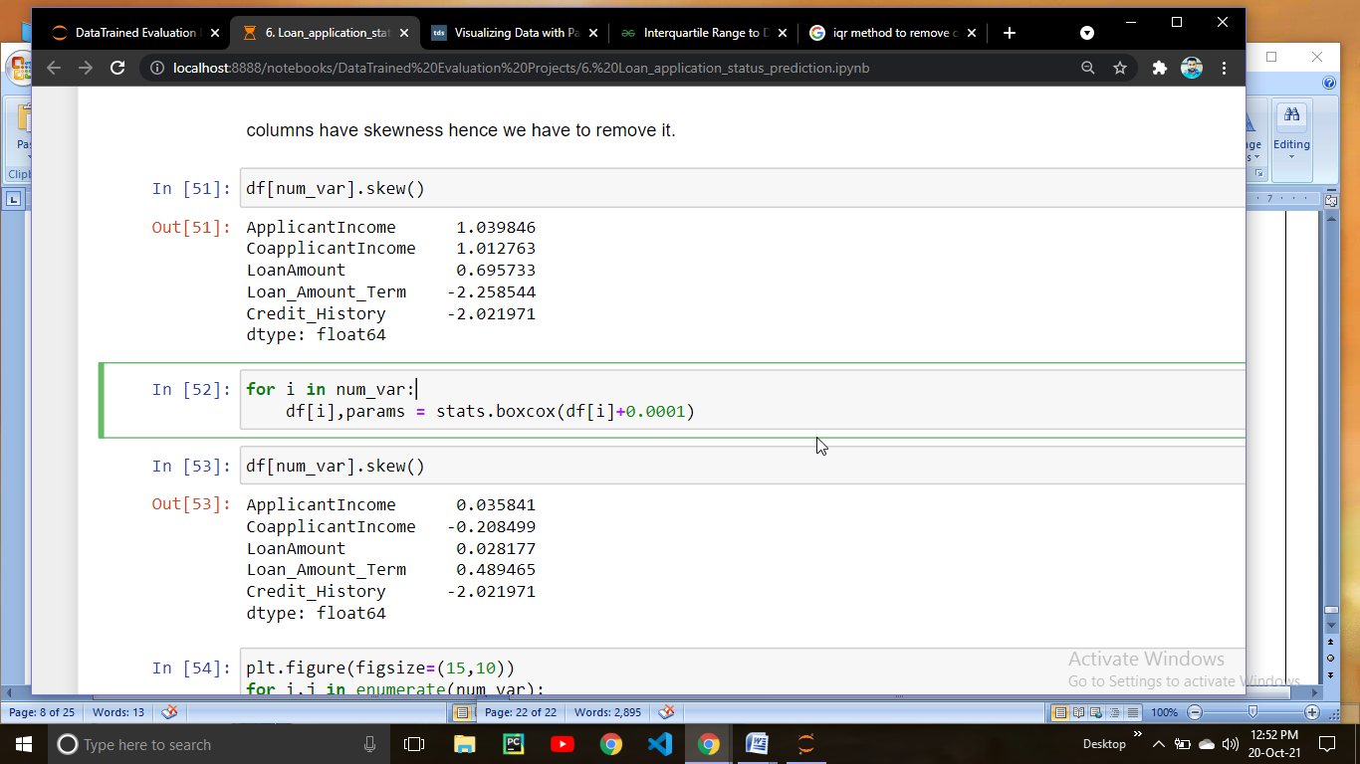

Lets check what happened after performing boxcox transformation.

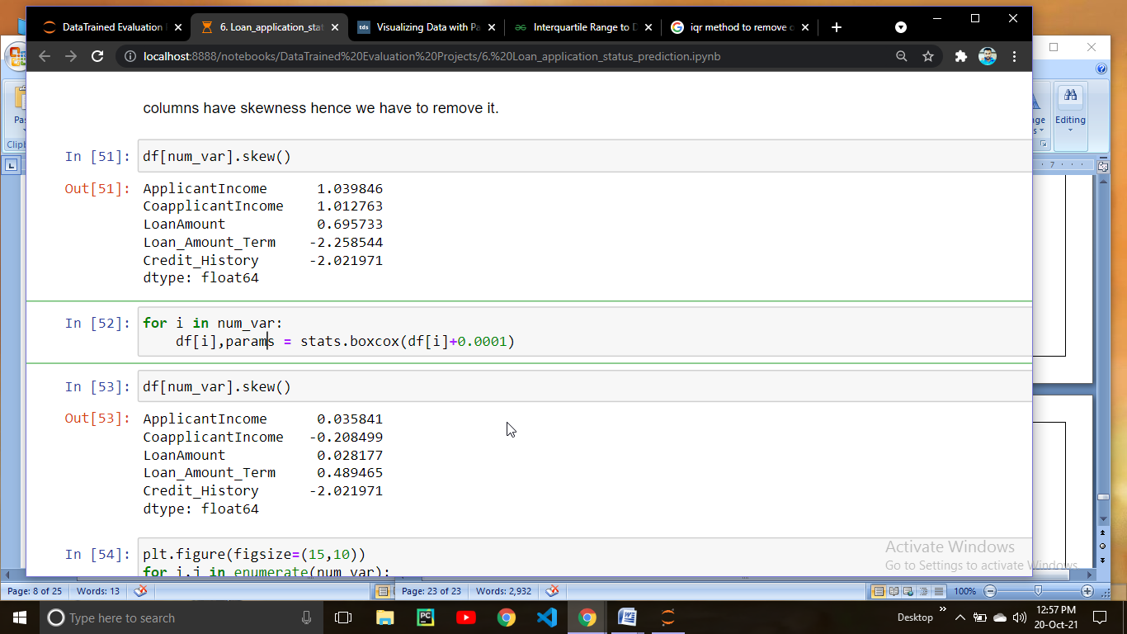

You can see that skewness has been removed from the columns,lets check the distribution after removing the skewness.

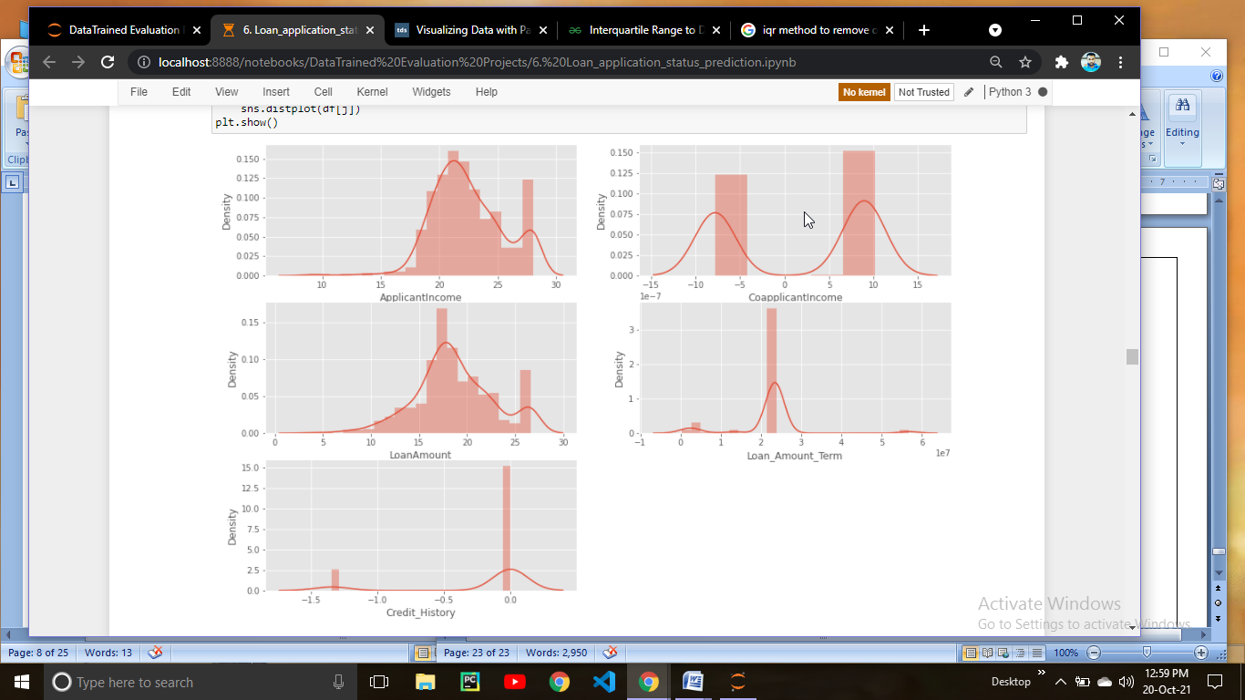

You can observed from the above distplot that all the columns looks normally distributed except Credit_History because this column has binary values.

Now this is the time to saperate the variables into input Features and output feature.

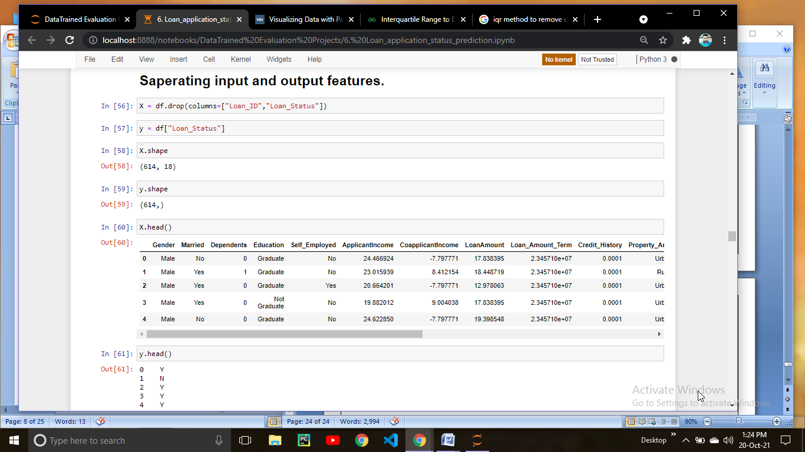

If you notice you will get to know that our data have some categorical variables so we have to handel them as well.

To perform encoding we are using ColumnTransformer from sklearn library.

To use ColumnTransformer you have to import from sklearn.compose import ColumnTransformer

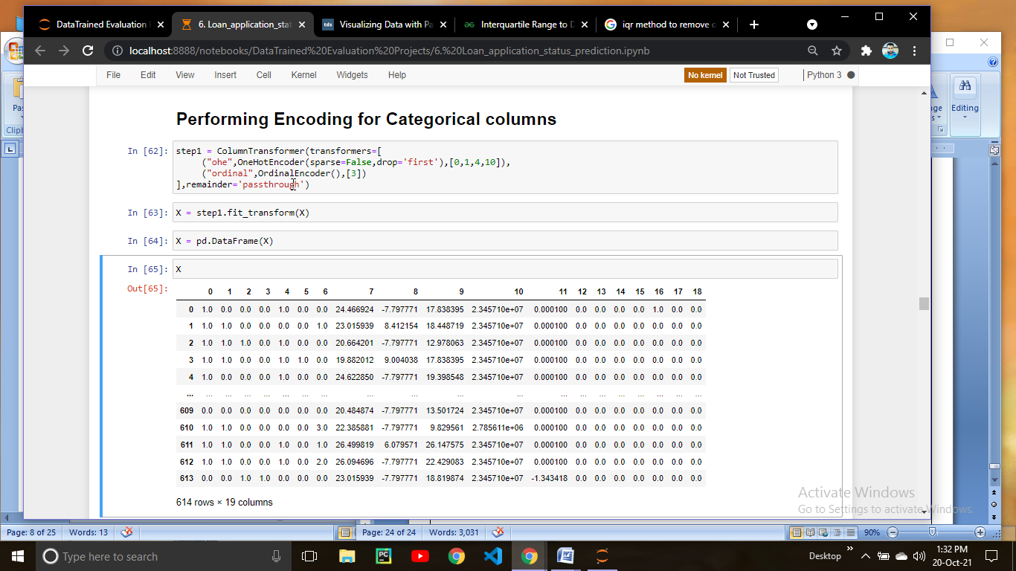

Performing Label Encoder for output column

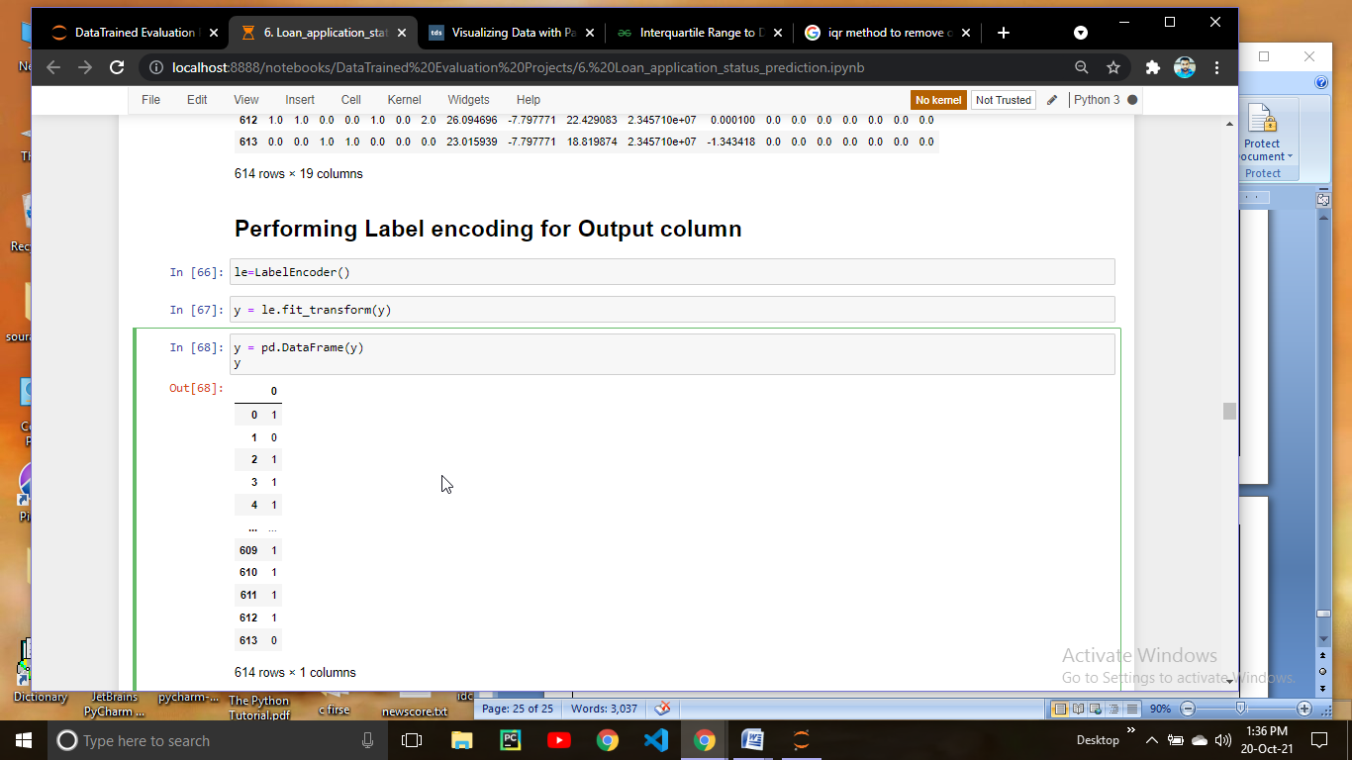

We know that our output classes are imbalanced so this is the time to make them balance.

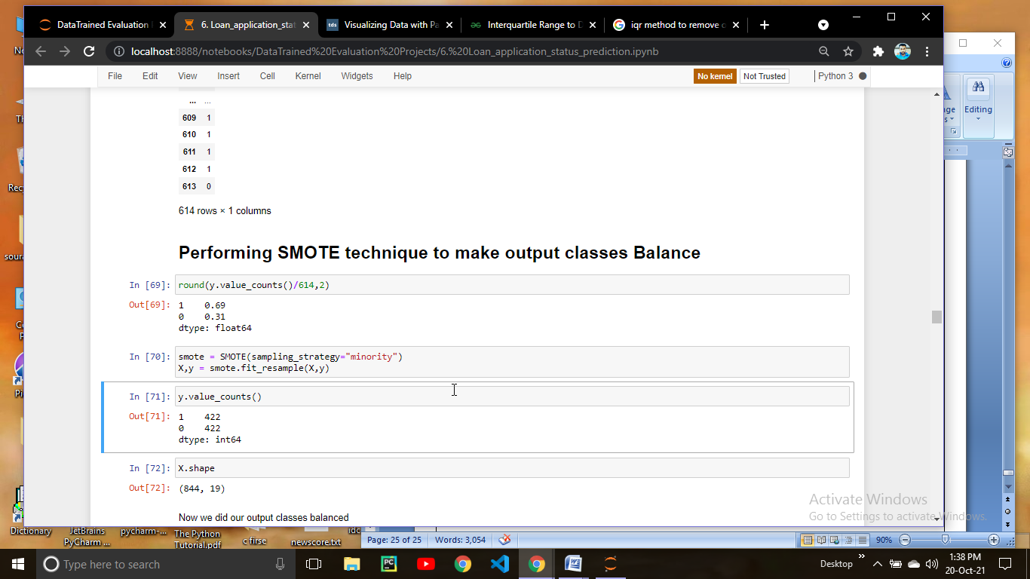

Now classes are balanced and we can move further.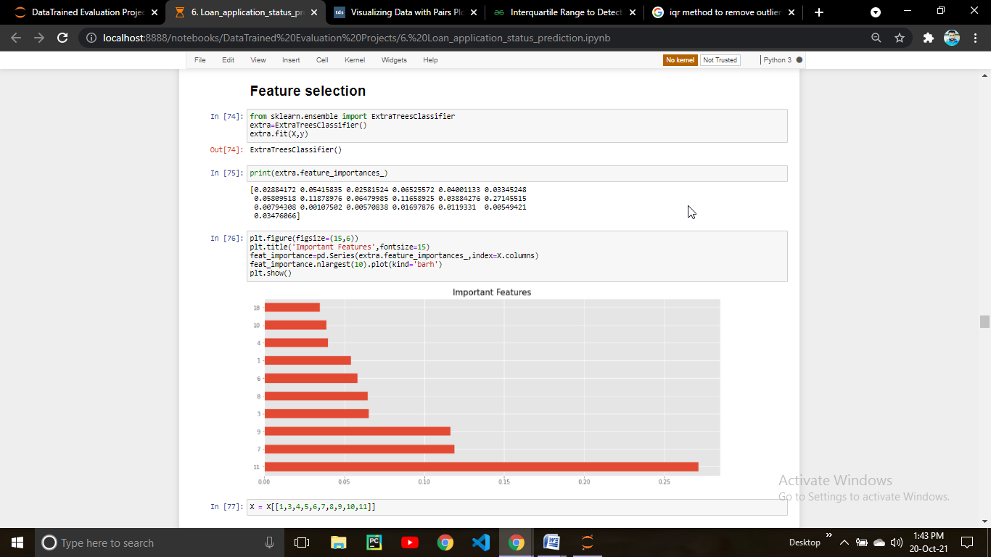

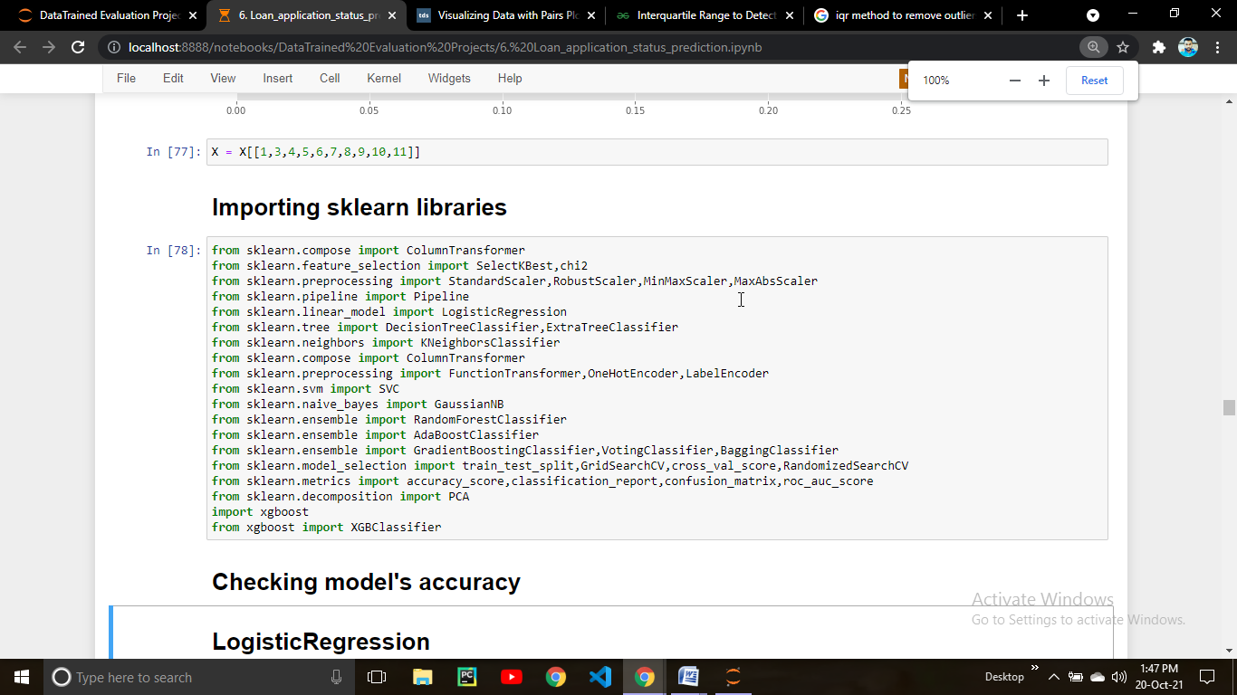

Here I created a sklearn pipeline which scale down the data into Standard Scaler and then apply Machine learning algorithm which checks for the best random state through which we can get the best random state where model makes less mistakes.

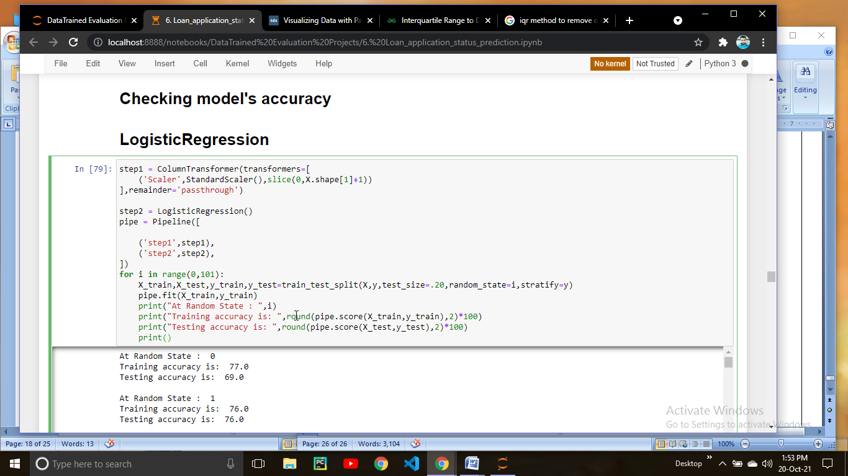

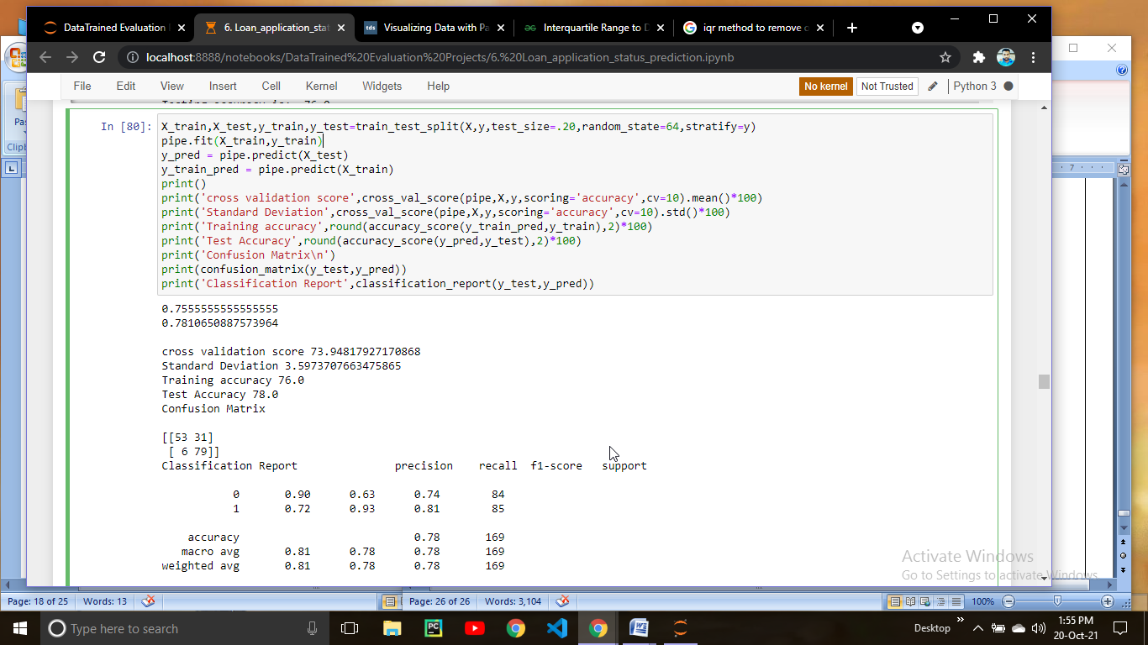

Similarly I checked for some more algorithms

# KNeighborsClassifier

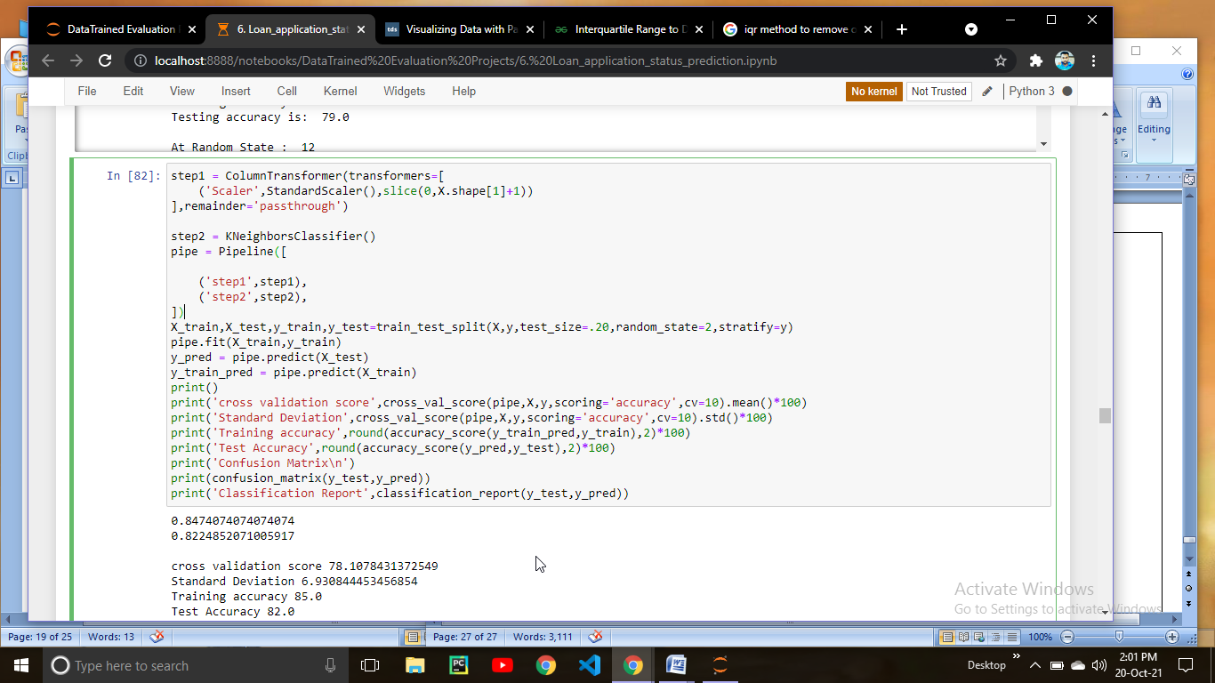

# Gradient Boosting

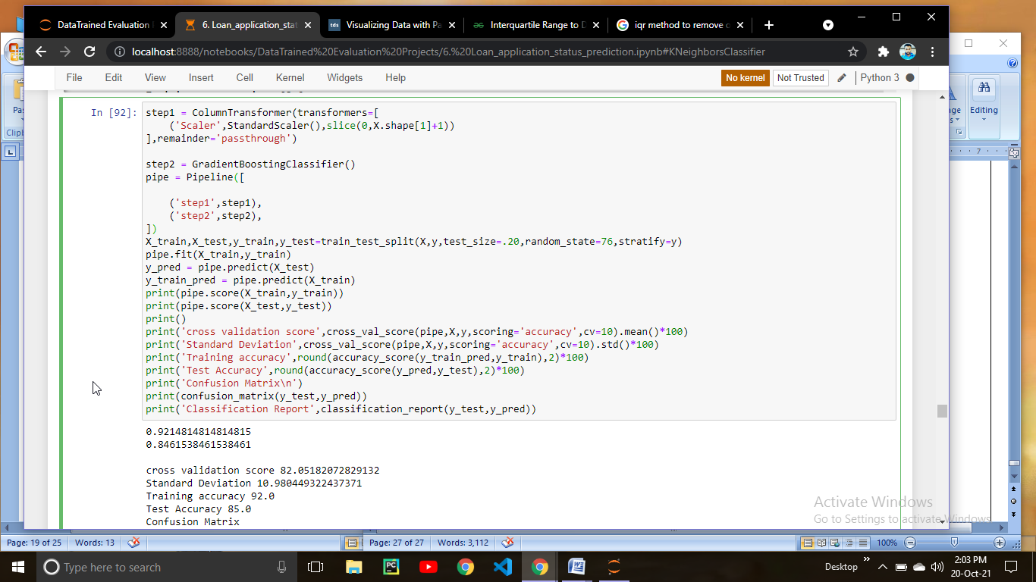

# BaggingClassifier

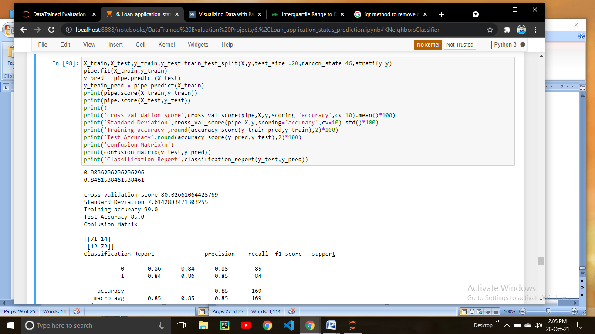

I tried many more algorithms among them Gradient Boosting Classifier performs well because cross val score is very near to accuracy score and we also got 85 % accuracy score.

So we are going to tune hyper parameters of Gradeint Boosting classifier.

# Hyper parameter tuning

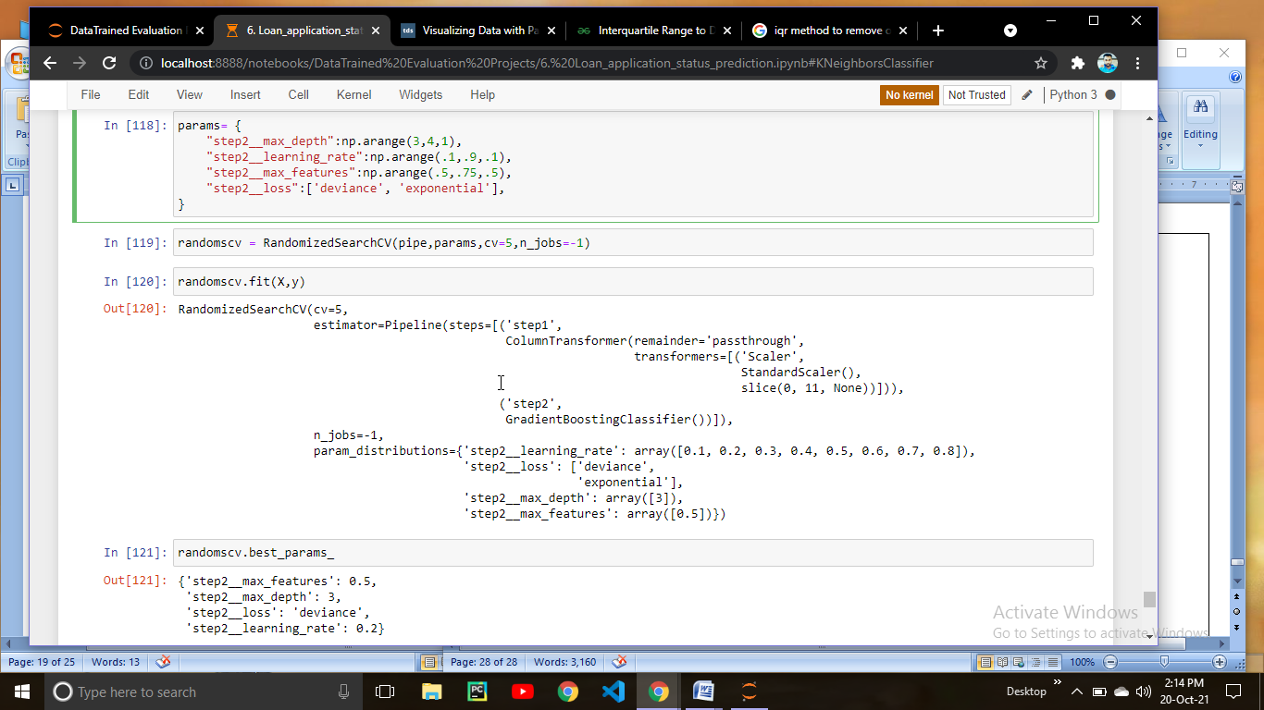

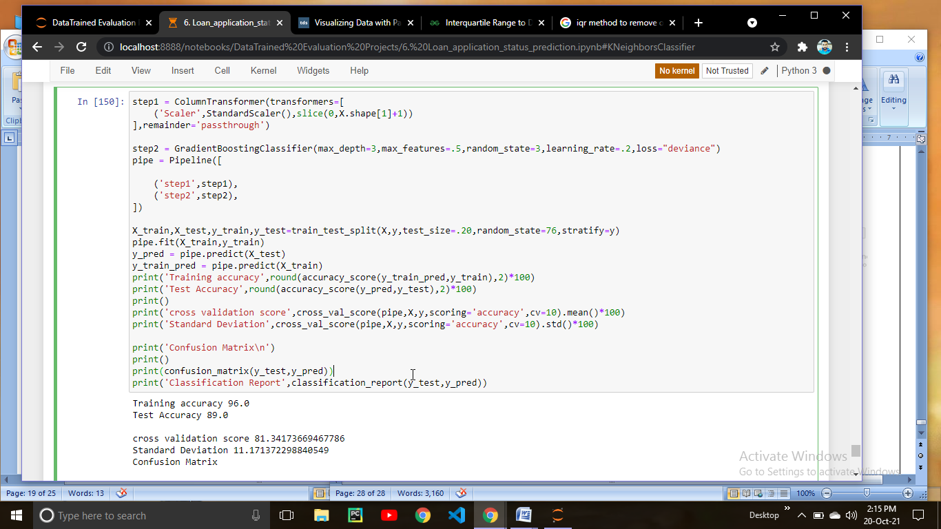

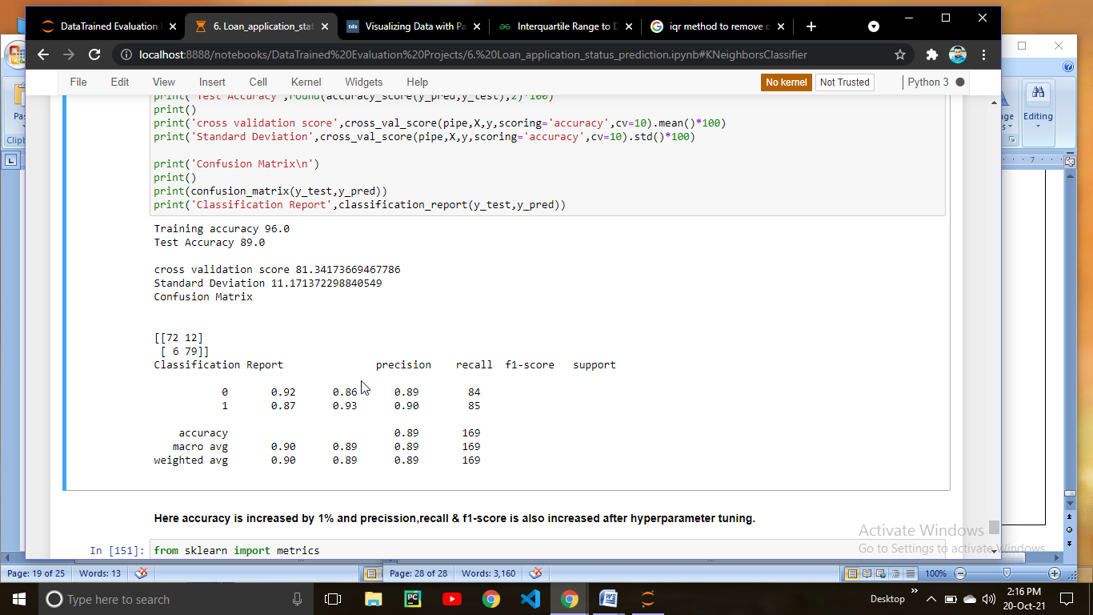

After hyper parameter tuning we can clearly see that accuracy is increased to 89 cross val score is 81,Precission,recall and f1-score is also increased.

Let check ROC Curve

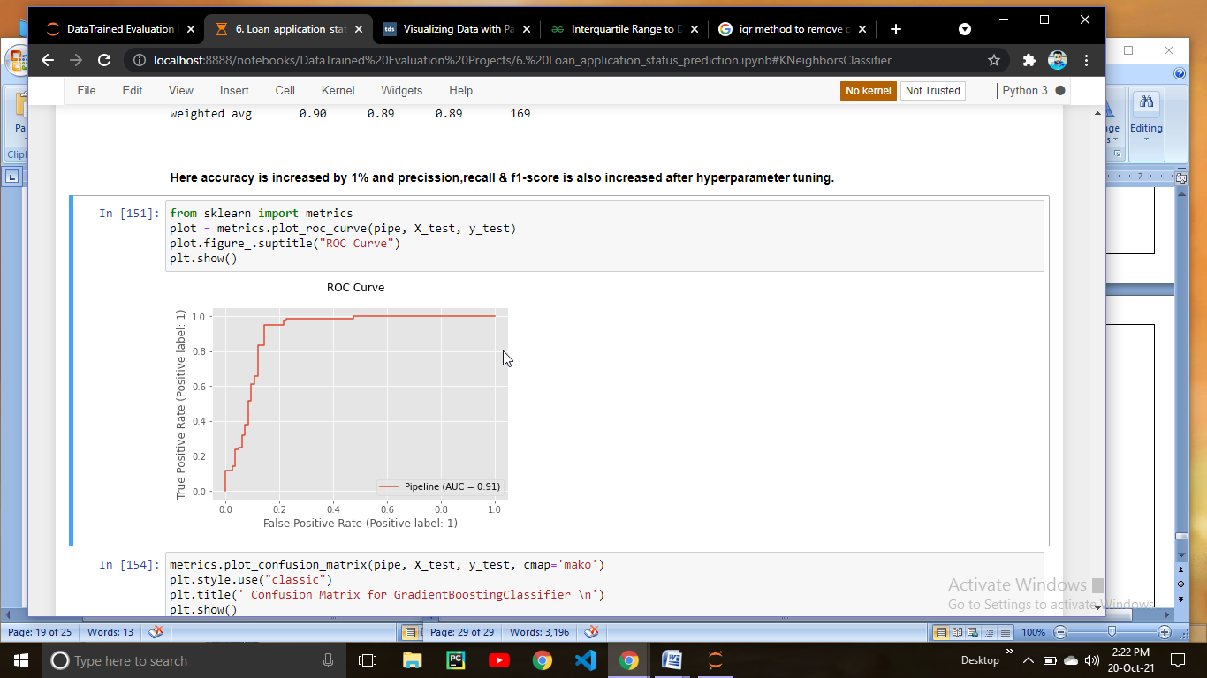

Lets check the confusion metrix

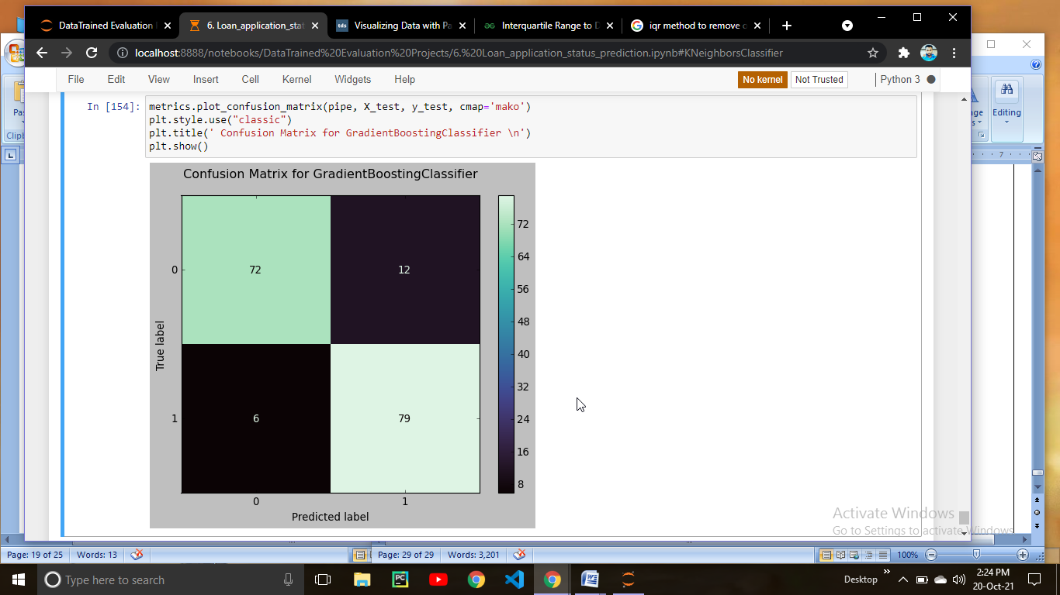

If you see the confusion metrix you can see False Negative & False Positive is decreased

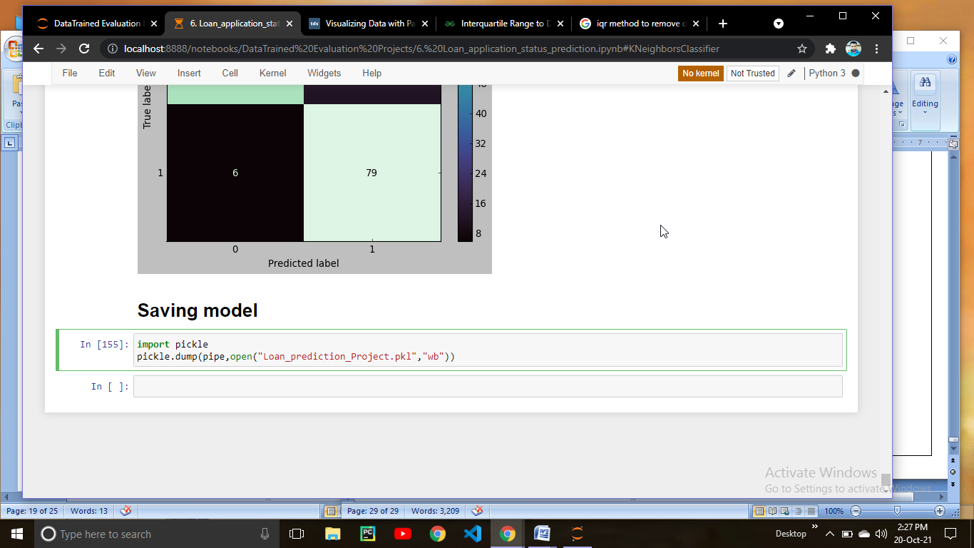

At last saving the model using Pickle